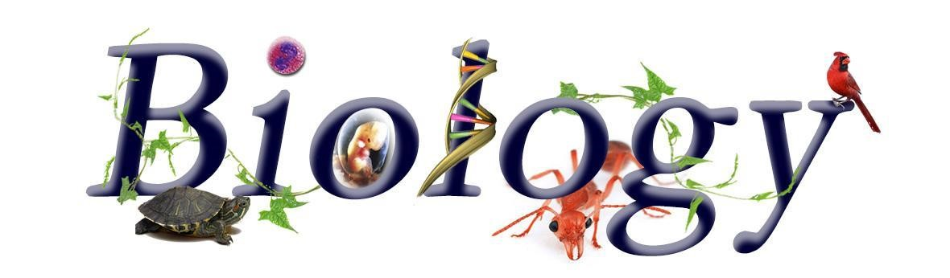

**Welcome to Biology A Level at The Holt ☺**

**As teachers we are passionate about our subject and as students choosing this subject we hope you are too! We are looking forward to working with you from September to achieve the highest grades you possibly can in a subject you will hopefully really enjoy.**

**This is a guide to help you get ready for A-level Biology, including everything from research ideas, pre knowledge tasks and things to watch and read.**

If you do have any questions or queries regarding A level Biology then please get in touch with Mrs Whitehouse over email. [g.whitehouse@holt.wokingham.sch.uk](mailto:g.whitehouse@holt.wokingham.sch.uk)

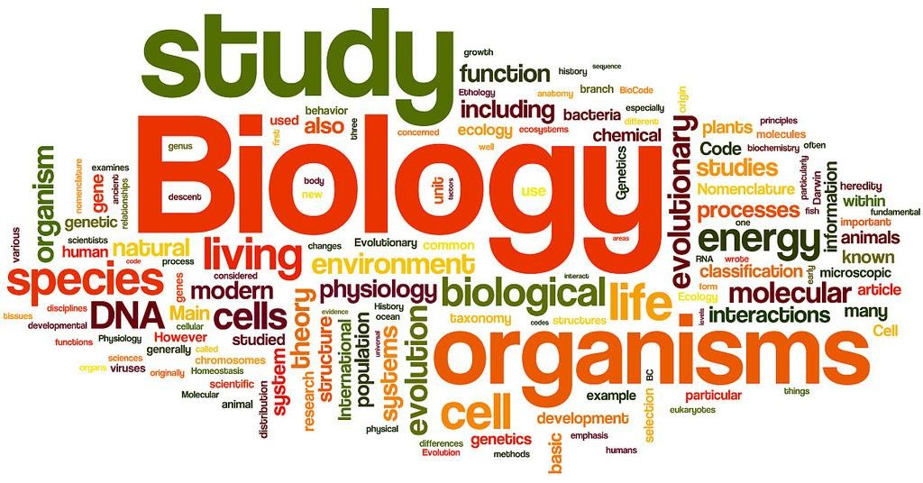

**Book Recommendations**

It is vital that you are accustomed to completing wider reading around topics you will cover during your A levels. As a starting point, we recommend the following titles:

*(remember, you can add these to your wider reading log in September!)*

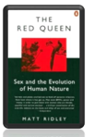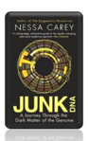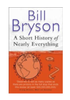[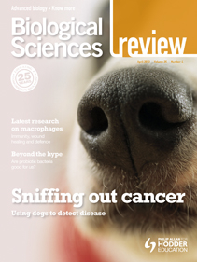](https://www.google.co.uk/url?sa=i&url=https://www.hoddereducation.co.uk/magazines/magazines-extras/biological-sciences-review-extras&psig=AOvVaw2Tnk7BeYl0A1LHQB7uOwBC&ust=1587822511590000&source=images&cd=vfe&ved=0CAIQjRxqFwoTCPiT6OSZgekCFQAAAAAdAAAAABAD) [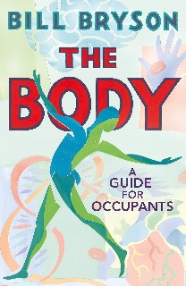](https://www.google.co.uk/url?sa=i&url=https://www.amazon.co.uk/Body-Guide-Occupants-Bill-Bryson/dp/085752240X&psig=AOvVaw2ksfWLH6UOjhM1G3cn0Sf0&ust=1587822552385000&source=images&cd=vfe&ved=0CAIQjRxqFwoTCJDS7vaZgekCFQAAAAAdAAAAABAD) [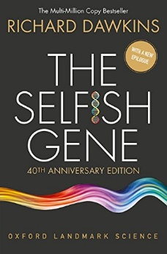](https://www.google.co.uk/url?sa=i&url=https://bookauthority.org/books/best-biology-books&psig=AOvVaw0YTYNURAgHID32ohWKQ-tZ&ust=1587822633359000&source=images&cd=vfe&ved=0CAIQjRxqFwoTCLiQ1puagekCFQAAAAAdAAAAABAF)

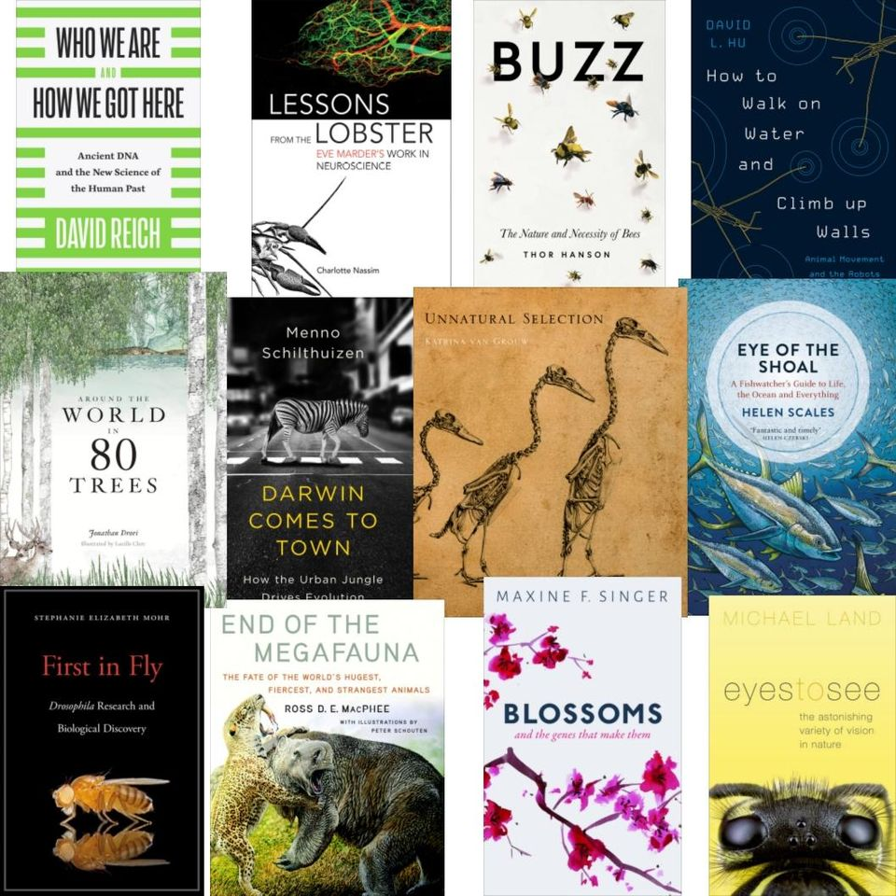

There are a huge array of books on biology topics.

From genetics to fish behavior, from the human body to evolution of all life.

You just have to choose your area ☺

If you want a good generic introduction, Bill Bryson comes highly recommended.

Biological sciences review is also available online through school.

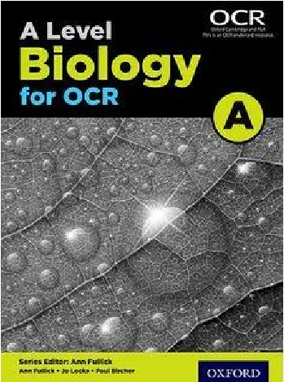

The text book we use in school for A level Biology is as follows:

Publisher: Oxford University Press

Editor: Ann Fullick

ISBN: 978-0-19-835192-4

The book contains all of the content for both years of the course.

(Separate books are available for year 1 and year 2, though it does

work out more expensive to buy them)

The book is also available for students to access for free through your kerboodle log in

**Film/ Documentary Recommendations**

There are a number of useful films and documentaries that will develop your wider understanding of the topics covered. If you do watch anything, keep a record of what it was and why you found it interesting, this will be helpful later on ☺

Older films:[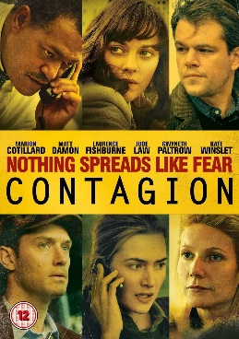](https://www.google.co.uk/url?sa=i&url=https://www.amazon.co.uk/Contagion-DVD-Matt-Damon/dp/B0058N2SBS&psig=AOvVaw3I4Zsrrf13GqYcvElicBUG&ust=1587823581260000&source=images&cd=vfe&ved=0CAIQjRxqFwoTCPC1i-GdgekCFQAAAAAdAAAAABAD)[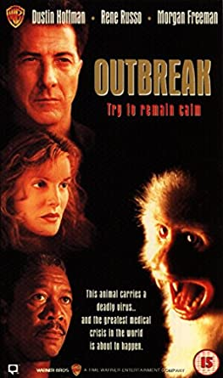](https://www.google.co.uk/url?sa=i&url=https://www.amazon.co.uk/Outbreak-VHS-Dustin-Hoffman/dp/B00004CUOL&psig=AOvVaw0ccGILk2_zgqArzDL9qOmf&ust=1587823532760000&source=images&cd=vfe&ved=0CAIQjRxqFwoTCNiW3cqdgekCFQAAAAAdAAAAABAD)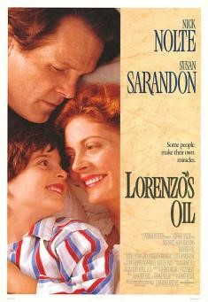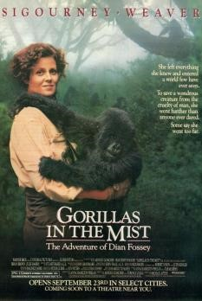

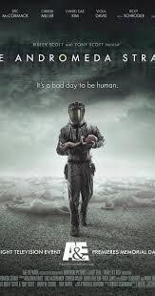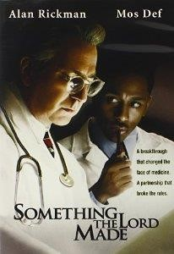Don’t forget the classic box sets available:

[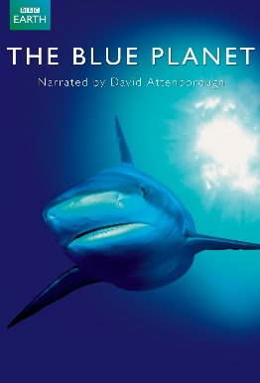](https://www.google.co.uk/url?sa=i&url=https://www.imdb.com/title/tt0296310/&psig=AOvVaw2eecqVqsfW5bx4bZ1riR5Q&ust=1587823673735000&source=images&cd=vfe&ved=0CAIQjRxqFwoTCJDu0oyegekCFQAAAAAdAAAAABAD)[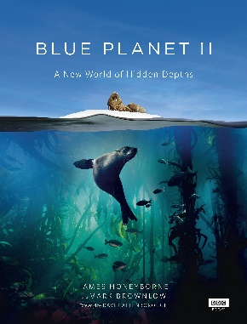](https://www.google.co.uk/url?sa=i&url=https://www.amazon.co.uk/Blue-Planet-II-James-Honeyborne/dp/1849909679&psig=AOvVaw2eecqVqsfW5bx4bZ1riR5Q&ust=1587823673735000&source=images&cd=vfe&ved=0CAIQjRxqFwoTCJDu0oyegekCFQAAAAAdAAAAABAJ)[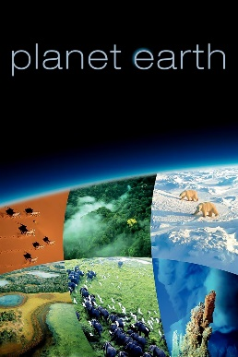](https://www.google.co.uk/url?sa=i&url=https://www.imdb.com/title/tt0795176/&psig=AOvVaw0QdYhbtzRPHyT-IpMQuvVI&ust=1587823726841000&source=images&cd=vfe&ved=0CAIQjRxqFwoTCKDErKaegekCFQAAAAAdAAAAABAD)[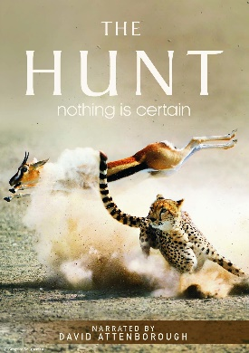](https://www.google.co.uk/url?sa=i&url=https://www.imdb.com/title/tt5167198/&psig=AOvVaw19oa84lSAZPZUxmkuziMMj&ust=1587823758179000&source=images&cd=vfe&ved=0CAIQjRxqFwoTCMjY47WegekCFQAAAAAdAAAAABAD)[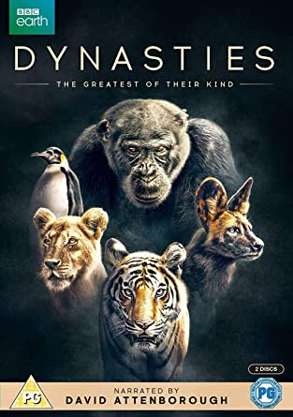](https://www.google.co.uk/url?sa=i&url=https://www.amazon.co.uk/Dynasties-DVD-Sir-David-Attenborough/dp/B07J2C2855&psig=AOvVaw2n23jo4-98OdYcidMKZgy3&ust=1587823794027000&source=images&cd=vfe&ved=0CAIQjRxqFwoTCODHtsWegekCFQAAAAAdAAAAABAD)[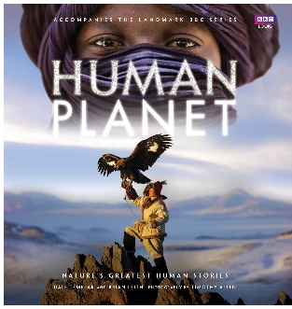](https://www.google.co.uk/url?sa=i&url=https://www.amazon.co.uk/Human-Planet-Dale-Templar/dp/184607956X&psig=AOvVaw3x0qRkSCwURKkfwjGP2IGx&ust=1587823846767000&source=images&cd=vfe&ved=0CAIQjRxqFwoTCJjavd-egekCFQAAAAAdAAAAABAJ)[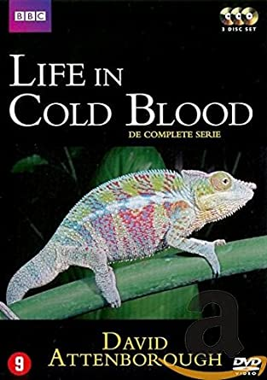](https://www.google.co.uk/url?sa=i&url=https://www.amazon.co.uk/Life-Cold-Blood-David-Attenborough/dp/9089412352&psig=AOvVaw1lzHb-1NjbFeU10DcOe2P4&ust=1587823895774000&source=images&cd=vfe&ved=0CAIQjRxqFwoTCJDd5_aegekCFQAAAAAdAAAAABAD)[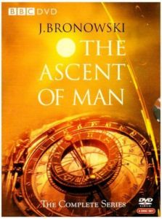](https://www.google.co.uk/url?sa=i&url=http://lib.english.cam.ac.uk/dvds/details/1860.html&psig=AOvVaw0yAEHOGgEkbPvasunpCGmR&ust=1587823922987000&source=images&cd=vfe&ved=0CAIQjRxqFwoTCMDV4YWfgekCFQAAAAAdAAAAABAD)[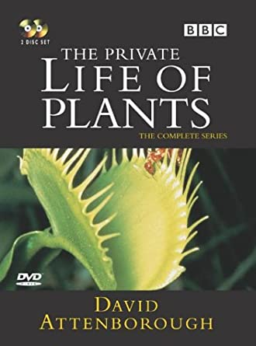](https://www.google.co.uk/url?sa=i&url=https://www.amazon.co.uk/David-Attenborough-Private-Life-Plants/dp/B0000AISJC&psig=AOvVaw0H3YufAUNc4oOlImxcXeaU&ust=1587823958109000&source=images&cd=vfe&ved=0CAIQjRxqFwoTCOjsmpSfgekCFQAAAAAdAAAAABAD)[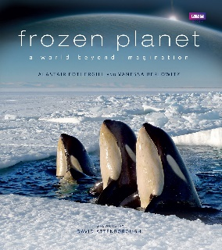](https://www.google.co.uk/url?sa=i&url=https://www.amazon.co.uk/Frozen-Planet-Alastair-Fothergill/dp/1846079624&psig=AOvVaw32-isgzadEg54wbJrgeGOm&ust=1587824001519000&source=images&cd=vfe&ved=0CAIQjRxqFwoTCOCouKmfgekCFQAAAAAdAAAAABAD)

Netflix and Amazon Prime also have lots of documentaries available, as do BBC iplayer – recommended at the moment by the biology department: <https://www.bbc.co.uk/iplayer/episode/m000h3nm/horizon-2020-9-coronavirus-special-part-1>

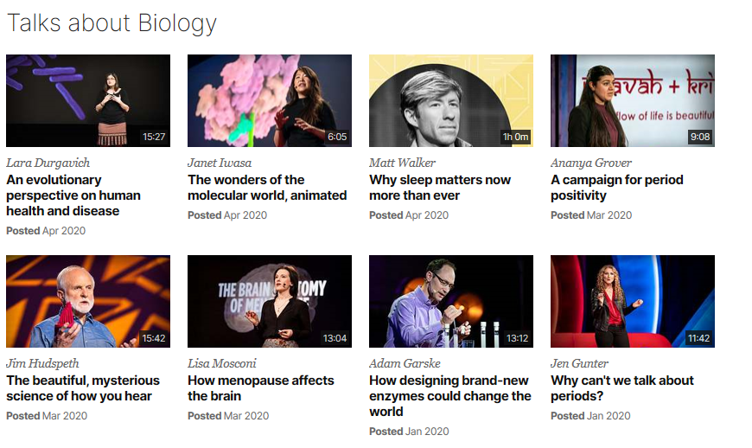Disney+ also has a lot of documentaries about specific species of animals ☺

You tube and Teded (available through the VLRC) are also good sources of videos!

<https://www.ted.com/topics/biology>

If you have 30 minutes to spare, here are some great presentations (and free!) from world leading

scientists and researchers on a variety of topics. They provide some intere

sting answers and ask

some thought

-

provoking questions. Use the link or scan the QR code to view:

**A New Superweapon in the fight against**

**Cancer**

Available at:

[n](http://www.ted.com/talks/paula_hammond_a_new_superweapon_in_the_fight_against_cancer?language=en)

[http://www.ted.com/talks/paula_hammo](http://www.ted.com/talks/paula_hammond_a_new_superweapon_in_the_fight_against_cancer?language=en)

[d_a_new_superweapon_in_the_fight_agai](http://www.ted.com/talks/paula_hammond_a_new_superweapon_in_the_fight_against_cancer?language=en)

[n](http://www.ted.com/talks/paula_hammond_a_new_superweapon_in_the_fight_against_cancer?language=en)

[st_cancer?language=e](http://www.ted.com/talks/paula_hammond_a_new_superweapon_in_the_fight_against_cancer?language=en)

[n](http://www.ted.com/talks/paula_hammond_a_new_superweapon_in_the_fight_against_cancer?language=en)

Cancer is a very clever, adaptable disease.

To defeat it, says medical researcher and

educator Paula Hammond, we need a new

and powerful mode

of attack.

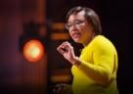

**Why Bees are disappearing**

Available at:

[http://www.ted.com/talks/marla_spivak](http://www.ted.com/talks/marla_spivak_why_bees_are_disappearing?language=en)

[_](http://www.ted.com/talks/marla_spivak_why_bees_are_disappearing?language=en)

[why_bees_are_disappearing?language=e](http://www.ted.com/talks/marla_spivak_why_bees_are_disappearing?language=en)

[n](http://www.ted.com/talks/marla_spivak_why_bees_are_disappearing?language=en)

Honeybees have thrived for 50 million

years, each colony 40 to 50,000

individuals coordinated in amazing

harmony. So why, seven years ago, did

colonies start dying en

-

masse?

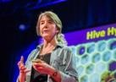

**Why Doctors don**

**’**

**t know about the**

**drugs they prescribe**

Available at:

[http://www.ted.com/talks/ben_goldacr](http://www.ted.com/talks/ben_goldacre_what_doctors_don_t_know_about_the_drugs_they_prescribe?language=en)

[e](http://www.ted.com/talks/ben_goldacre_what_doctors_don_t_know_about_the_drugs_they_prescribe?language=en)

[_](http://www.ted.com/talks/ben_goldacre_what_doctors_don_t_know_about_the_drugs_they_prescribe?language=en)

[_what_doctors_don_t_know_about_the](http://www.ted.com/talks/ben_goldacre_what_doctors_don_t_know_about_the_drugs_they_prescribe?language=en)

[drugs_they_prescribe?language=e](http://www.ted.com/talks/ben_goldacre_what_doctors_don_t_know_about_the_drugs_they_prescribe?language=en)

[n](http://www.ted.com/talks/ben_goldacre_what_doctors_don_t_know_about_the_drugs_they_prescribe?language=en)

When a new drug

gets tested, the results

of the trials should be published for the

rest of the medical world

—

except much

of the time, negative or inconclusive

findings go unreported, leaving doctors

and researchers in the dark.

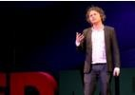

**Growing new organs**

Avai

lable at:

[http://www.ted.com/talks/anthony_at](http://www.ted.com/talks/anthony_atala_growing_organs_engineering_tissue?language=en)

[a](http://www.ted.com/talks/anthony_atala_growing_organs_engineering_tissue?language=en)

[la_growing_organs_engineering_tissue](http://www.ted.com/talks/anthony_atala_growing_organs_engineering_tissue?language=en)

[?](http://www.ted.com/talks/anthony_atala_growing_organs_engineering_tissue?language=en)

[language=e](http://www.ted.com/talks/anthony_atala_growing_organs_engineering_tissue?language=en)

[n](http://www.ted.com/talks/anthony_atala_growing_organs_engineering_tissue?language=en)

Anthony Atalla's state

-

of

-

the

-

art lab

grows human organs

—

f

rom muscles to

blood vessels to bladders, and more.

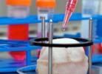

**Research Ideas**

If you want to take a deeper look at some of the content you will be covering during your A Level in Biology, here are some big picture topic resources you can use. You could write a summary of which ever area you look at, this could then be added to your notes when you cover this topic in year 12. It will also help your understanding if you have covered some of the content before, as not everything will be new ☺

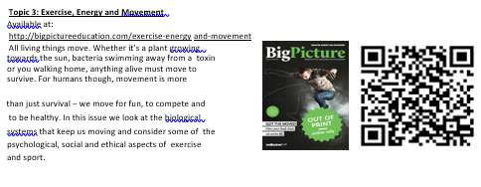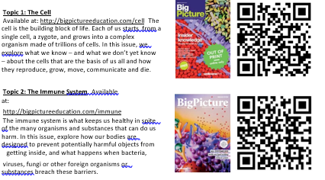

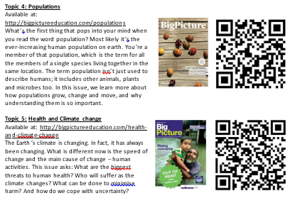

**Online resources**

There are innumerable resources available, this is just a tiny selection!

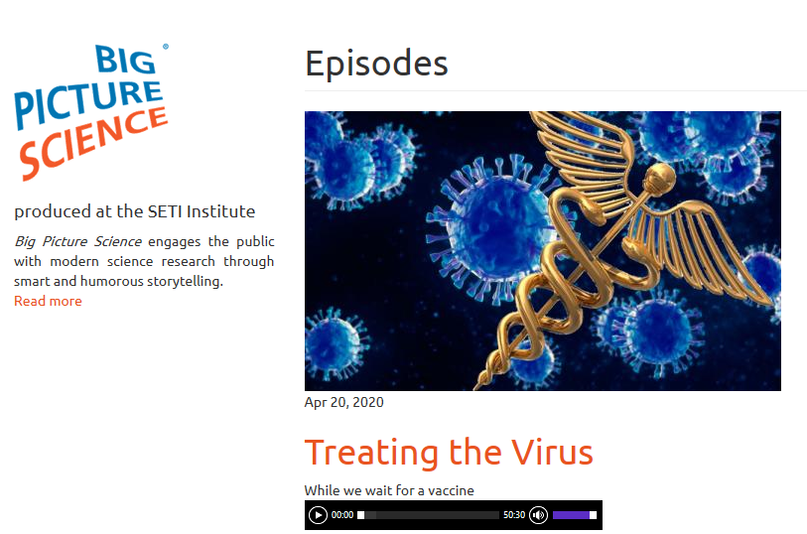Big Picture Science in association with the Seti Institute also does blogs: <http://radio.seti.org/episodes>

This is their latest offering!

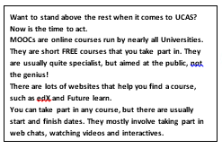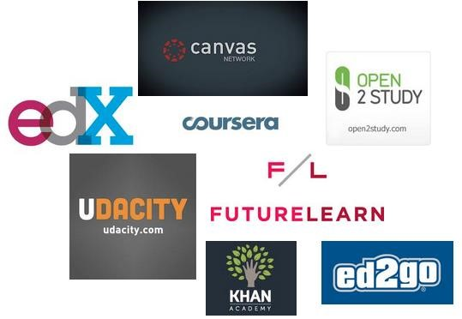There are online courses available:

Zoos and museums have a lot of online resources:

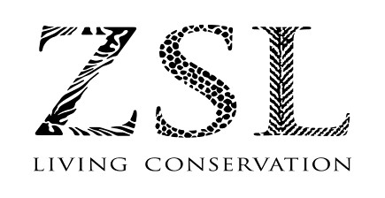[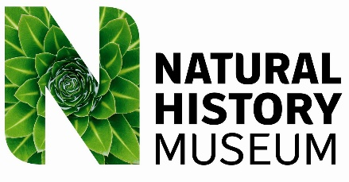](https://www.google.co.uk/url?sa=i&url=https://geobon.org/natural-history-museum-logo/&psig=AOvVaw2GGcRzUKhqAI5QnE7Xu5H4&ust=1587825678593000&source=images&cd=vfe&ved=0CAIQjRxqFwoTCKjcicilgekCFQAAAAAdAAAAABAD)[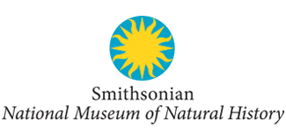](https://www.google.co.uk/url?sa=i&url=https://www.youraudiotour.com/tours/1&psig=AOvVaw2P8hT0Ev0TwlKzyZvK1nZ0&ust=1587825727968000&source=images&cd=vfe&ved=0CAIQjRxqFwoTCKjovd-lgekCFQAAAAAdAAAAABAD)

[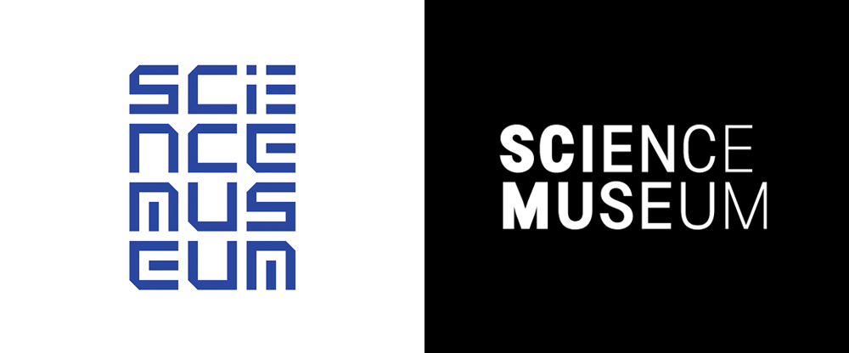](https://www.google.co.uk/url?sa=i&url=https://www.underconsideration.com/brandnew/archives/new_logo_and_identity_for_science_museum_by_north.php&psig=AOvVaw1-fRCu3O7X8k7RvCn95vOG&ust=1587825761879000&source=images&cd=vfe&ved=0CAIQjRxqFwoTCKilx_GlgekCFQAAAAAdAAAAABAD)

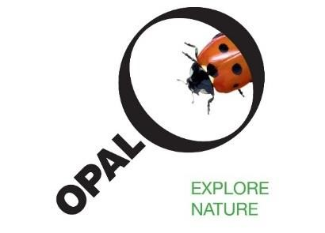Or take part in citizen science projects:

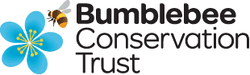



**Useful Pre-Knowledge Tasks – there is no expectation to complete these**

1. **Symbols and Prefixes**

Standard form is commonly used in Biology, try and learn the prefixes, symbols and powers of ten ready for September.

|  |  |  |
| --- | --- | --- |
| **Prefix** | **Symbol** | **Power of ten** |
| Nano | n | x 10-9 |
| Micro | μ | x 10-6 |
| Milli | m | x 10-3 |
| Centi | c | x 10-2 |
| Kilo | k | x 103 |
| Mega | M | x 106 |
| Giga | G | x 109 |

1. **Produce a glossary for the following key words:**

accuracy, anomaly, calibration, causal link, chance, control experiment, control group, control variable,

correlation, dependent variable, errors, evidence, hypothesis, independent, null hypothesis, precision,

probability, protocol, random distribution, random error, raw data, reliability, systematic error, true value,

validity and zero error

1. Answer the following questions;
   1. What are the 4 bases found in DNA? Can you spell them correctly? Can you describe the full structure of DNA
   2. What are the constituents of a balanced diet?
   3. What theory did Charles Darwin propose? Can you describe the full process?
   4. Draw and fully label a plant and animal cell? Can you give a function for each component?
   5. What is an enzyme? Describe in full the lock and key theory? Can you explain how the 4 factors affect enzyme action?
   6. Describe the stages of mitosis?
   7. Write the word and balanced chemical equations for aerobic respiration, anaerobic respiration in animals and in plants/yeast and photosynthesis
   8. Write the advantages and disadvantages of light and electron microscopes
   9. Explain how to do the biological molecules tests, what are positive results?
   10. What is the structure of the heart? Can you add all the labels to a diagram?

Cells and biological molecules are the first topics taught in September.

**Have a lovely summer and remember if you have any questions or queries about the Biology A Level course then please email Mrs Whitehouse 😊**