  A Level

CHEMISTRY

TRANSITION BOOKLET

Welcome to the Chemistry A level course here at The

Holt School. You are going to be studying the OCR A H432 Specification. To ensure that you reach your potential in this subject you need to:

* Complete this transition booklet, which revisits all the necessary concepts learnt at GCSE in readiness to build on these at A level. Check your answers and come with questions for areas that you are unsure.
* Complete the Research Activity highlighted in the

Transition Resources Document

* Print off a version of the specification:

[http://www.ocr.org.uk/qualifications/as-a-level-gce-chemistry-ah032-h432-from-2015/.](http://www.ocr.org.uk/qualifications/as-a-level-gce-chemistry-a-h032-h432-from-2015/)

We follow Chemistry OCR A H432 specification.

* You need to buy the following text book and bring it to every lesson

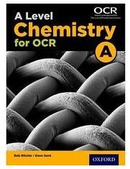

ISBN: 978 019835197 9

By [Rob Ritchie](https://www.amazon.co.uk/s/ref=dp_byline_sr_book_1?ie=UTF8&text=Rob+Ritchie&search-alias=books-uk&field-author=Rob+Ritchie&sort=relevancerank) (Author), [Dave Gent](https://www.amazon.co.uk/Dave-Gent/e/B00NW35XGI/ref=dp_byline_cont_book_2)

* Use relevant websites to help you refresh and extend your knowledge:

**Useful Websites:**

<http://www.bbc.co.uk/scotland/learning/bitesize/higher/chemistry/> <http://www.s-cool.co.uk/alevel/chemistry.html><http://www.docbrown.info/><http://www.knockhardy.org.uk/sci.htm><http://www.chemguide.co.uk/>

<http://www.mp-docker.demon.co.uk/home.html>

The RSC (The Royal Society of Chemistry) is also a good website that you can use.

* Read around the subject to broaden your knowledge and curiosity:

**Magazines**

Chemistry Review, Cosmos

## Books

A Short History of Nearly Everything – Bill Bryson

Chasing the Molecule – John Buckingham

The Elements: A Very Short Introduction- Philip Ball

Bad Science – Ben Goldacre

Everyday Practice of Science: Where Intuition and Passion Meet Objectivity and Logic – Frederick Grinnell

The Age of Wonder – Richard Holmes

The Elements: A Visual Exploration of Every Known Atom in the Universe- Theodore Gray

Oxygen: The Molecule That Made the World- Nick Lane

• You will also need a scientific calculator.

We believe in: hard work ˜ perseverance ˜ organisation ˜ commitment leads to success in Chemistry!



## Contents

1. ATOMIC STRUCTURE 4

2. BONDING 5

3. GROUP 1: THE ALKALIS METALS 10

4. GROUP 7: THE HALOGENS 11

5. ACIDS 11

6. BASES 12

7. NEUTRALISATION 12

8. CALCULATIONS 13

9. RATES 16

10. PRACTICE QUESTIONS 17

11. ANSWERS TO PRACTICE QUESTIONS 19

**MOLES ..........................** ERROR! BOOKMARK NOT DEFINED.

**(T**HIS IS AN EXTRA PART IF YOU STUDIED TWENTY

CENTURY SCIENCE AT GCSE**) ....................................................**

**PRACTICE QUESTIONS .............** ERROR! BOOKMARK NOT DEFINED.

**ANSWERS ...................** ERROR! BOOKMARK NOT DEFINED.

**Read the following to recall the key concepts that you learnt at GCSE. Do all the questions and then check the answers. Bring the completed Booklet on your first lesson back in September.**

# ATOMIC STRUCTURE

|  |  |  |
| --- | --- | --- |
| Particle | Charge | Mass |
| Proton | 1+ | 1 |
| Neutron | 0 | 1 |
| Electron | 1− | 1/2000 (almost)0 |

Structure of an Atom:

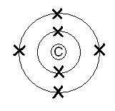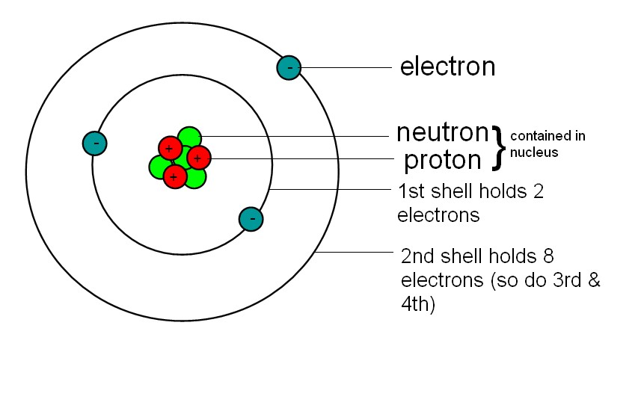 (1)

Mass Number = number of protons + number of neutrons

Atomic number = The number of protons

Number of Neutrons = mass number − atomic number (number of protons)

Number of electrons = number of protons (atoms are neutral)

Isotopes: atoms with the same number of protons, but different numbers of neutrons e.g. 12C and 14C.

# BONDING

Covalent Bonding: shared pair of electrons between non-metal atoms.

Example:

Carbon has 4 electrons on its outer shell and needs 4 more to complete a full outer shell.

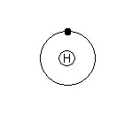Hydrogen has 1 electron in its outer shell and because it’s the first shell, it only needs 1 more to have a full outer shell.

Therefore carbon and hydrogen share its electrons to achieve a full outer shell and become more stable: There is a strong electrostatic attraction between the shared the pair of electrons and the two nuclei so Covalent bonds are STRONG

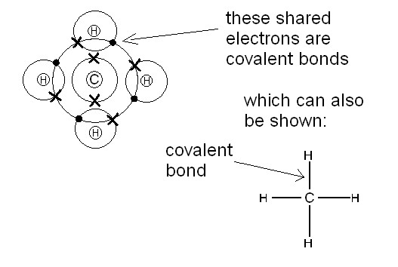

Double Bonding: this is when two pairs of electrons are shared. Example:

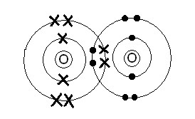

Can also be shown as:

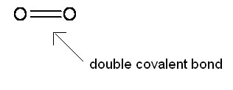

There are 2 types of structures Simple eg Hydrogen molecule

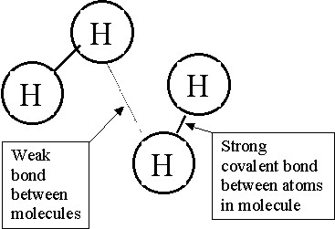

Giant Covalent structures eg Diamond, Graphite

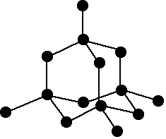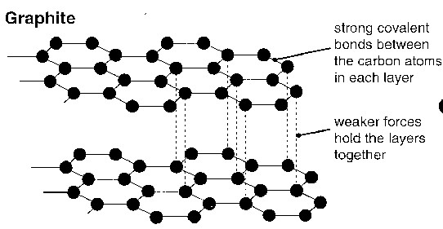

Properties:-

* SIMPLE COVALENT STRUCTURES-low melting /boiling points – weak forces between the molecules (inter molecular forces). GIANT COVALENT STRUCTURES – high melting and boiling points as there is a network of strong covalent bonds to overcome
* poor solubility- no charges for water to attract
* poor electrical conductors- no free electrons/ions to carry the charge except GRAPHITE

Ionic Bonding: formed between metals and non-metals. Electrostatic attraction between oppositely charged ions

Example:

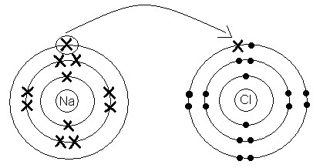

Show final ions in square brackets;

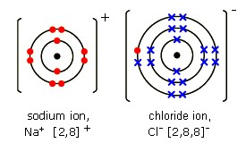

Atoms are more stable with a full outer shell. Sodium wants to lose an electron to gain a full shell and chlorine wants to gain an electron. So sodium gives its electron to chlorine and forms an ionic bond.

Because sodium has now got 10 electrons and 11 protons, its charge becomes 1+. And chlorine has 18 electrons and 17 protons therefore its charge becomes 1−.

Na+ and Cl− are opposite charges and therefore attract and bond very strongly.

This is electrostatic attraction.

They all have Giant LATTICE Structures:

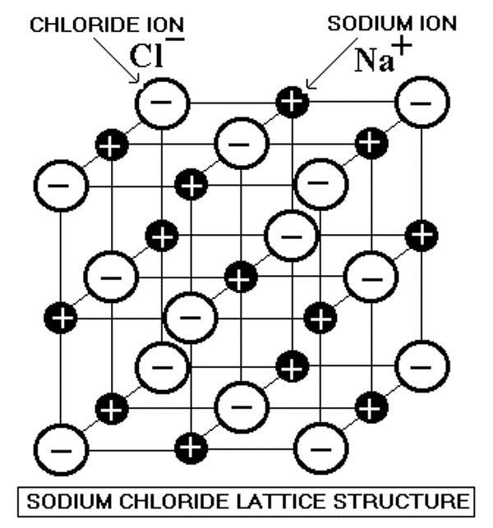

Properties:-

* made of crystals-regular arrangement of oppositely charged ions
* high melting/boiling points- strong forces of attractions between oppositely charged ions
* often soluble in water- water can attract the oppositely ions
* conduct electricity when melted or as a solution as they have free ions to carry the electrical charge

Formulas of ionic compounds

To work out the formula of ionic compound the charges must be equal and opposite to make the overall charge neutral.

Magnesium chloride : Mg2+  Cl1-  = 1: 2 MgCl2

You need to learn the polyatomic ions: OH- , NO3 - , SO4 2- , CO3 2- , NH4 +

Metallic Bonding

Structure - atoms packed closely

* + giant structures

Properties

* + high melting point/boiling point- strong attraction between the cations and electrons
  + good conductor of heat and electricity - free electrons
  + hard and dense - ions packed together
  + malleable - external force applied the structure is retained - ductile

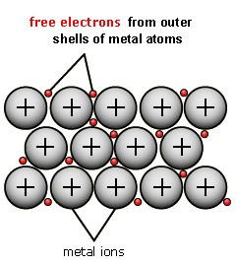

Each metal atom gives up one or more of its electrons into the “sea” of electrons (delocalised).

These electrons are free to move about in the metal which explains how electricity can pass through metal solids.

# GROUP 1: THE ALKALIS METALS

Li Na K Rb Cs

 Most reactive

The reason why it is more reactive as you go down a group is because the atom gets bigger and the outer electron is further away from the nucleus. Therefore the outer electron gets further away from the attractive force of the nucleus which makes it easier to get rid of.

Properties:-

* relatively low melting points
* low densities • very soft
* very reactive
* shiny surface

alkali metal + water → alkali metal hydroxide + hydrogen

2X(s) + 2H2O(l) → 2XOH(aq) + H2(g)

Observations- fizzes, dissolves, universal indicator goes purple pH 13-14 strong alkali, floats K- sets alight purple flame, Na- molten ball

alkali metal + oxygen → alkali metal oxide

4X(s) + O2(g) → 2X2O(s)

alkali metal + chlorine → alkali metal chloride

2X(s) + Cl2(g) → 2XCl(s)

# GROUP 7: THE HALOGENS

F Cl Br I At

 Least reactive

The reason why it gets less reactive as you go down a group is due to the size of the atom. For example, fluorine is a lot smaller than iodine. Therefore, an electron entering the outer shell of a fluorine atom is nearer to the attractive force of the nucleus. So the electron is attracted more strongly.

|  |  |  |
| --- | --- | --- |
| HALOGEN MOLECULE | COLOUR | STATE (at room temp) |
| F2 | pale yellow colour | Gas |
| Cl2 | yellow/green | Gas |
| Br2 | orange/brown | Liquid |
| I2 | Grey (purple vapour) | Solid |

All halogens’ atoms form diatomic molecules. This means they like to form pairs e.g. F2 and Cl2.

Displacement: if the halogen is more reactive than the halogen solution, it will displace it out of the solution.

Example:

chlorine + potassium bromide → potassium chloride + bromine

Cl2(aq) + 2KBr(aq) → 2KCl(aq) + Br2(aq)

Chlorine is more reactive than bromine so it is displaced and forms potassium chloride.

# ACIDS

pH scale

RED GREEN PURPLE

1 2 3 4 5 6 7 8 9 10 11 12 13 14



Most acidic

Some examples of are:

HCl(aq)

H2SO4(aq)

HNO3(aq)

acid + alkali → salt + water eg HCl(aq)+NaOH(aq) → NaCl(aq) + H20(l)

acid + Metal carbonate → salt + water + carbon dioxide

H2SO4(aq)+ CaCO3(S) → CaSO4(aq)+H2O(l)+ CO2 (g)

acid + metal → salt + hydrogen gas

2HNO3(aq) + Mg(S) → Mg(NO3)2(aq) + H2(g)

It is the H+(aq) ions that make a solution acidic.

# BASES

pH scale

RED GREEN PURPLE

1 2 3 4 5 6 7 8 9 10 11 12 13 14



Most alkaline

Some examples are:

NaOH

ZnO

KOH

Alakis are soluble bases eg NaOH, Ca(OH)2

base + acid → salt + water

It is the OH−(aq) ions that make a solution alkaline

# NEUTRALISATION

pH scale

RED GREEN PURPLE 1 2 3 4 5 6 7 8 9 10 11 12 13 14

neutral

pH 7 is neutral. H2O is neutral.

Neutralisation Equation

H+(aq) + OH−(aq) **→** H2O(l)

The H+ and OH− ions cancel each other out and form H2O.

# CALCULATIONS

Relative Atomic Mass (R.A.M): the average mass takes into account the different proportions of each isotope in the natural mixture.

Example:

If the two isotopes of a sample of chlorine consist of 75% 35Cl and 25% 37Cl, then

75 x 35 = 26.25

100

+

25 x 37 = 9.25

100 = 35.5

R.A.M of Cl = 35.5

Relative Formula Mass (R.F.M): the R.A.M.s in the formula added together.

Example:

Al2(SO4)3

R.A.M.s; Al=27, S=32, O=16

2Al; 2x27=54

3S; 3x32=96 +

12O; 12x16=192 = 342

R.F.M of Al2(SO4)3 = 342

Percentage of an Element in a Compound =

no. of atoms of element in compound formula x R.A.M x 100

R.F.M of compound

Using the example above, calculate the percent of Al in Al2(SO4)3.

R.A.M of Al = 27

R.F.M of Al2(SO4)3 = 342

2x27 x 100 = 15.8%

342

### MOLES

Moles of Atoms = mass or mass

R.A.M R.F.M

Moles of Gas = volume of gas (dm3)

24

Number of Moles = Concentration (molarity) x volume of solution (cm3)

1000

Converting cm3 to dm3:

There are 1000cm3 in 1dm3

To convert cm3 in to dm3, you divide by 1000.

To convert dm3 in to cm3, you multiply by 1000

Moles in Equation

We can use balanced equations to predict the masses of products:

1. Write the balanced equation

1. Circle the information given and what you want to find out

1. Convert the moles into masses (using RFM)

1. Use logical steps to arrive at your final answer

Example:

A student adds 4.8g of magnesium to excess dilute hydrochloric acid. What mass of magnesium chloride would be made? (R.A.M.s; Mg = 24, Cl = 35.5)

1.

Mg + 2HCl → MgCl2 + H2

2.



3.

Mg = 24g MgCl2 = 24+ (2x35.5)=95g

4.

If 24g of Mg gives us 95g of MgCl2 then 1g of Mg gives us 95/24g of MgCl2

Therefore, 4.8g of Mg give us 95/24 x 4.8g = 19g

Working out the Formula

We can use moles to work out a formula.

1. Find the number of moles of each element in the compound; mass

R.F.M

1. Then work out the ratio of the number of moles of each element, to the lowest whole number

Example:

Work out the formula for each of the compounds made from 14g of nitrogen and

0.3g of hydrogen –

1. Moles of N = 1.4/14 = 0.1

Moles of H = 0.3/1 = 0.3

1. N : H

0.1 : 0.3 divide by the lowest number 1 : 3

We have 3 times as many H atoms as N atoms in this compound.

Therefore the formula is NH3

# RATES

Collision Theory: Particles must collide and collide with enough energy (activation energy) in order to get a chemical reaction- successful collision

Rate of Reaction: How quickly a chemical reaction happens - The change in concentration of reactant/product over time. The reaction is fastest at the beginning as it is most concentrated so more frequent collisions. As the reaction proceeds the solution becomes more diluted and number of collisions decreases.

Where the graph flattens the reaction comes to an end.

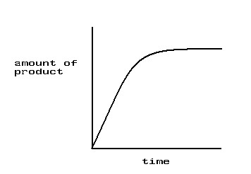

Factors that increase the rate of reaction:

* larger surface area – Greater number of exposed particles so more frequent collisions leads onto more successful collisions
* higher concentration- More particles in a given volume so more frequent collisions
* higher temperature – Particles have more energy and so collide more frequently and more particles exceed the activation energy so leads to more successful collisions
* higher pressure particles closer together n a given volume so leads to more frequent collisions so faster reaction
* catalyst – this lowers the activation energy by finding an alternative route and so more particles exceed the activation energy so they collide more successfully and increases the speed of reaction

Activation energy: the minimum energy needed to start a reaction

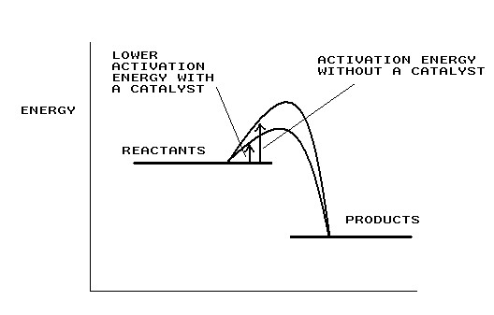

# PRACTICE QUESTIONS

1.

1. Draw a dot and cross diagram for LiF.
2. Draw a dot and cross diagram for CO2

2.

1. Write a word and symbol equation for potassium and water.
2. Write a word and symbol equation for lithium and oxygen.
3. Write a word and symbol equation for sodium and chlorine

3.

1. Write a word and symbol equation for chlorine reacting with potassium bromide.
2. Write a word and symbol equation for bromine reacting with potassium iodide

4.

1. Write a symbol equation for potassium hydroxide and nitric acid.
2. Write a symbol equation for copper II carbonate and hydrochloric acid.
3. Write a symbol equation for sodium and sulfuric acid
4. Write a symbol equation for ammonia and sulfuric acid

5.

Mg has 3 isotopes; 78.7% of Mg-24, 10.13% of Mg-25, 11.17% of Mg-26. Calculate the R.A.M of Mg.

6.

1. Calculate the % of nitrogen in ammonium nitrate (NH4NO3).
2. Calculate the % mass of oxygen in NaNO3

7.

1. State what can affect the rate of a reaction
2. What is the collision theory
3. Why does the temperature, concentration and catalyst affect the rate of reaction (use the collision theory)

8. a) Write an equation to show what happens when an acid is neutralised

* 1. What would you observe when calcium carbonate is added to sulphuric acid
  2. How could measure the rate of this reaction and sketch a graph what your results would show

9.

* 1. How many moles of atoms are there in 2.4g of carbon?
  2. How many moles of atoms are there in 0.19g of fluorine?

10.

* 1. How many moles of molecules are there in 170g of NH3?
  2. How many moles of molecules are there in 0.3g of C2H6?

11.

* 1. How many moles of gas molecules are there in 6dm3 of hydrogen gas?
  2. How many moles of gas molecules are there in 120cm3 of oxygen gas?

12.

* 1. What volume does 3 moles of hydrogen gas occupy at room temperature and pressure?
  2. What volume does 0.1 mole of nitrogen gas occupy at room temperature and pressure?

13.

* 1. What volume does 8g of oxygen gas occupy at room temperature and pressure?
  2. What volume does 8.8g of carbon dioxide gas occupy at room temperature and pressure?

14.

If you add 5.3g of sodium carbonate to excess dilute sulphuric acid, what mass of sodium sulphate would be made? (R.A.M.s; Na=23, C=12, O=16, S=32).

15.

* 1. Work out the formula for the compound made from 12g of carbon and 4g of hydrogen.
  2. Work out the formula for the compound made from 11.2g of iron and 4.8g of oxygen.
  3. Work out the formula for the compound made from 3.2g of copper,

0.6g of carbon and 2.4g of oxygen.

(R.A.M.s; C=12, H=1, O=16, Fe=56, Cu=64

# ANSWERS TO PRACTICE QUESTIONS

1. a)

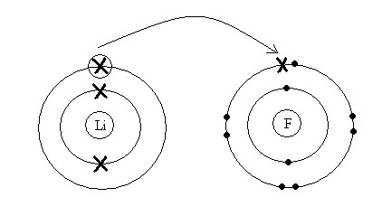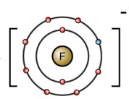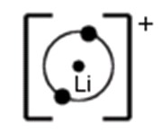

Show with square brackets final ions

b)

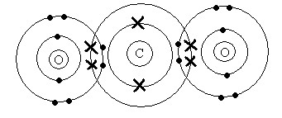

1. a)

potassium + water → potassium hydroxide + hydrogen

2K(s) + 2H2O(l) → 2KOH(aq) + H2(g)

b)

lithium + oxygen → litium oxide

4Li(s) + 2O2(g) → 2Li2O(s)

c)

sodium + chlorine → sodium chloride

2Na(s) + Cl2(g) → 2NaCl(s)

1. a)

chlorine + potassium bromide → potassium chloride + bromine

Cl2(aq) + 2KBr(aq) → 2KCl(aq) + Br2(aq)

b)

bromine + potassium iodide → potassium bromide + iodine

Br2(aq) + 2KI(aq) → 2KBr(aq) + I2(aq)

4.a) potassium hydroxide + nitric acid → potassium nitrate + water

KOH(aq) + HNO3(aq) → KNO3(aq) + H2O(l)

1. copper II carbonate + hydrochloric acid → copper chloride + water + carbon dioxide

CuCO3(s) + 2HCl(aq) → CuCl2(aq) + H2O(l) + CO2(g)

1. Sodium + sulfuric acid → magnesium sulphate + hydrogen

2Na(s) + H2SO4(aq) → Na2SO4(aq) + H2(g)

1. ammonia + sulfuric acid

2NH3 (aq) + H2SO4(aq) → (NH4 )2 SO4(aq)

5.

78.7/100 x 24 = 18.9

10.13/100 x 25 = 2.5 +

11.17/100 x 26 = 2.9

24.3

6.a)

2 x N = 2 x 14 = 28

4 x H = 4 x 1 = 4 +

3 x O = 3 x 16 = 48

formula mass = 80

b)

Na = 1 x 23 = 23

O = 3 x 16 = 48 +

N = 1 x 14 = 14

85

48/85 x 100 = 56.5%

7.

1. Temperature, concentration/pressure/surface area, catalyst

1. For a reaction to occur the particles must collide and collide with enough energy called the activation energy

1. Temperature- particles have more kinetic energy so will collide more frequently and more particles will collide successfully as more particles exceed the activation energy.

Concentration – Particles closer together so collide more frequently

Catalyst- Lowers the activation energy so more particles will exceed the activation energy and so collide more successfully

8.

1. H+(aq) + OH−(aq) → H2O(l)

1. Fizzing, solid will disappear

1. Collect and measure how quickly the is produced gas over water, Measure how quickly the mass decreases.



9.moles of atoms = mass/RAM

1. 2.4/12 = 0.2 moles

1. 0.19/19 = 0.01 moles

10.moles of molecules = mass/RFM

a)170/17 = 10 moles

b) 0.3/30 = 0.01 mole

11. moles = volume of solution /24 (in dm3)

1. 6/24 = 0.25 moles

1. there are 1000 cm3 in a dm3 so don’t forget to times it by 1000

120/24 x 1000 = 0.005 mole

12.volume (dm3) = no. of moles x 24

1. 3 x 24 = 72 dm3
2. 0.1 x 24 = 2.4 dm3

13.a) RFM of O2 = 16 x 2 = 32 moles = mass/RFM = 8/32 = 0.25 mole

volume of gas (dm3) = moles x 24 = 0.25 x 24 = 6dm3 0f O2

b) RFM of CO2 = 12 + (16 x 2) = 44

moles = mass/RFM = 8.8/44 = 0.2 mole

volume of gas (dm3) = moles x 24 = 0.2 x 24

= 4.8 dm3

Na2CO3 + H2SO4 → Na2SO4 + CO2 + H2O

RFM of Na2CO3 = 106

RFM of Na2SO4 = 142

1. 1g → 142/106 therefore 5.3g → 142/106 x 5.3g = 7.1g

1. a) moles of C = 12/12 = 1 moles of H = 4/1 = 4

CH4

1. moles of Fe = 11.2/56 = 0.2

moles of O = 4.8/16 = 0.3

Fe2O3

1. moles of Cu = 3.2/64 =0.05 moles of C = 0.6/12 = 0.05 moles of O = 2.4/16 = 0.15

CuCO3