A Level Geography

So you have chosen to study Geography at A level. Congratulations!
“Geography is the subject which holds the key to our future" - Michael Palin,
There has never been a better or more important time to study A level Geography. It is one of the most relevant subjects, you could choose to study. You will enjoy the scope of the material we cover in lessons, the insights it can provide into the world around us and the highly contemporary nature of the issues it tackles.
The A level Geography course is split into human and physical geography even though geography is a very fluid subject with some of the issues overlapping. I have given details of the Exam board etc. in the information below. We have also set some tasks to help you prepare for the course as well as some things we recommend that you could read, listen to or watch.

We are looking forward to working with you all in September – in the meantime, there are loads of things for you to do to start you on your journey to becoming an A Level Geographer!
Exam Board Information
AQA Geography 7037

Units of Study:
Component 1 Physical Geography
- Water and carbon cycles
- Coastal systems and landscapes
- Hazards
Component 2 Human Geography
- Global systems and global governance
- Changing places
- Population and the environment
Component 3 Geographical Investigation
Individual investigation, which must include four days of data collection in the field.

Text Books
Core text book ( we would recommend purchasing this book)  Companion text books ( we have these available in school) | AQA A-Level Geography (For A-Level and AS) 4th Edition  Malcom Skinner et. al  Hodder Education (2016) ISBN: 978-1-4718-5869-7  AQA A-Level and AS Physical Geography Student Book  Simon Ross e al.  Oxford University Press (2016)  ISBN: 978-0-19-836651-5  AQA A-Level and AS Human Geography Student Book  Simon Ross et al.  Oxford University Press (2016)  ISBN: 978-0-19-836654-6
Task 1 Human Geography Changing Places - Local Place Study

The specification says ‘as part of this unit we must undertake a local place study exploring the developing character of a place local to the home’. We study Wokingham as our local place,

- Location of Wokingham
Find maps of different types and scales to illustrate the location and characteristics of Wokingham
- The History of Wokingham
Research the history of Wokingham – it has been quite bloody at times!
Create a time line of key events.
(I do have instructions for a History Walk of Wokingham – if you contact me, I will send it to you.)
- Representation of Wokingham – collect examples of Wokingham as it has been portrayed in visual media, paintings, photographs, maps etc.
- Has Wokingham ever been represented in song, film, or poetry… ?(see what you can find!).

All of this information will be a part of our local place study of Wokingham.

Task 2 Human Geography Population and the Environment – Environment, Health & Wellbeing

The specification says’ Global patterns of health, mortality and morbidity. Economic and social development and the epidemiological transition. The global prevalence, distribution, seasonal incidence of one specified biologically transmitted disease.’

Research Task The Geography of the Coronavirus
This is going to be a long-term research project. We study Health in Year 13. You will need to plan the research carefully – taking account of times and dates.

- What is the coronavirus?
- How did it spread geographically ( type in geography of coronavirus and there are some useful interactive maps(take care with data sources though - see below)
- What are the Impacts?
  - Immediate impacts – this is what is happening now
  - Long term impacts – we do not know these yet - this will be ongoing research
  - Immediate responses – how has the world (find out about the WHO here), countries and localities responded?
  - Long Term responses – we will have to wait and see...
For each of these headings – find examples at different scales e.g.
- Globally – the WHO role
- Nationally choose the UK and a contrasting country
- Locally – what is happening in your local area?

Questions to consider
- What has been/is the/will be the social, economic and environmental impact?
- Is there any difference between the impacts and responses in HICs/LICs/NEEs?
- What factors influenced the different impacts and responses…etc.etc..

But take care – make sure you look carefully at the data
Consider -
- What is the source of the data – how reliable should this be?
- What is the date of publication?
- Look carefully at axis in graphs and calculations of statistics are do they give a skewed picture?
- Are they comparing like with like?
- Who is the data for?

This will form part of the Year 13 course when we study Health.

Any questions - please email Mr Mosely on r.mosely@holt.wokingham.sch.uk

Task 3 Physical Geography – Natural Hazards

https://www.nationalgeographic.com/environment/natural-disasters-weather/
https://www.bbc.co.uk/bitesize/topics/zcdrbk7

- Investigation: Distribution of Geographical Hazards:
What major geographical hazards have occurred globally within the last 5 years? Consider carefully how you can represent the different types of hazards and their concentrations on a map(s). Your map should be A4 or A3 in size with a clear key, title etc. Comment on your map findings.

- Factfile creation: Choose one specific type of hazard from each of the categories below:
- Geophysical Hazard
- Hydrological Hazard
- Atmospheric Hazard
- Geomorphic Hazard
- Biohazard
- Write up a brief factfile on one named hazard event in each category anywhere in
the world. Be as current as possible.
Headings for your factfile are:
    - Location of the event
    - Nature of the event
    - Impacts (How could you categorise?)
    - Human responses to the hazard (risk management through preparedness, mitigation, and adaption

Task 4 Physical Geography – Coasts

https://www.bbc.co.uk/bitesize/topics/zs3ptyc
http://www.coolgeography.co.uk/gcsen/PL_Holderness_Coastline.php
https://www.internetgeography.net/topics/coasts/dorset-coast/

- A description of the UK coast.

You can either do this as an annotated map of the whole of the UK, or as a piece of written work, with paragraphs for different parts of the UK.

The regions you could focus on:
- South Dorset coast (Jurassic)
- Cornwall
- South East of England (Kent/ Essex)
- Norfolk
- Holderness coast (East Yorskhire)
- East and West coasts of Scotland
- Wales Coast

For each one, see if you can find what features of erosion and deposition the coast is famous for, which make it a unique landscape.

See if there are any issues in the area to do with coastal management, for example erosion/ deposition/ controversy over what is being done.

It would be good to find some images to add to your map/ written work.

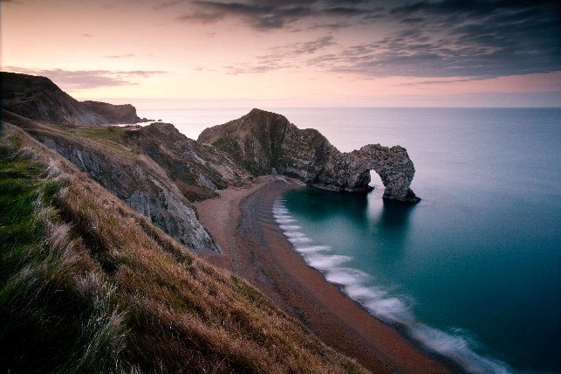

Any questions - please email Mrs Wragg on j.wragg@holt.wokingham.sch.uk

Things you can read

Books
Prisoners of Geography: Ten Maps That Tell You Everything You Need to Know About Global Politics by Tim Marshall
Geography: Ideas in Profile by Danny Dorling & Carl Lee
What is Radical About Geography? by Danny Dorling
Walking the Amazon by Ed Stafford (DVD & book)
Tropic of Capricorn by Simon Reeve (DVD & book)/ Tropic of Cancer by Simon Reeve (DVD & book)
Factfulness by Hans Rosling et al.

Things you can watch
Horizon with Chris Packham – will be on BBCiplayer
Hans Rosling - Don’t Panic available on youtube and the Gapminder website
Race around the World – also currently on BBC
Raging Planet/ Planet Earth I and II/ Earth: Power of the Planet
Any Simon Reeve documentary, e.g. The Americas
Around the World in 80 days/ Sahara/ Full Circle etc – Michael Palin.
Andrew Marr’s Megacities/ Britain from Above.
The Impossible (2017)
State of the Planet – a series made in 2001 and presented by David Attenborough.
Human Planet – 8 part BBC documentary series (2011)
Slumdog Millionaire
Erin Brockovich - a good film that presents the negative impacts of the natural gas industry and the extent to which large companies are prepared to go to, to cover this up.

Websites you can visit
Geographical Association https://www.geography.org.uk/teaching-resources/Secondary-and-post-16-resources#
The British Geographers - http://thebritishgeographer.weebly.com/
Royal Geographical Society - http://www.rgs.org
Gap minder (Statistics and Human Geography) - https://www.gapminder.org/
Google Earth - https://www.google.co.uk/intl/en_uk/earth/
Time for geography - https://timeforgeography.co.uk/

Watch anything by Hans Rosling on TED talks https://www.ted.com/playlists/474/the_best_hans_rosling_talks_yo
Maps that show us who we are (not just where we are) | Danny Dorling: https://www.youtube.com/watch?v=iWaZEXBbQL0
Worldmapper – www.worldmapper.org

Emergency Events Database – http://www.emdat.be/
Intergovernmental Panel on Climate Change – www.ipcc.ch
The Guardian Climate change- https://www.theguardian.com/environment/climate-change
The BBC Coast series - www.bbc.co.uk/coast/
If you have any questions or comments or find any other sites, films, books that you would like to recommend please email Mrs Wragg at j.wragg@holt.wokingham.sch.uk

