
Guide to Enrolment- The Holt School
Internal Students: You must enrol between 8:30am and 12pm on the 20th August to secure your place.
If you have met the grades for your courses and you are remaining with your original choices you are able to enrol online
Step 1:
Log in to your Applicaa account (the same site as your application form) https://theholtschool.applicaa.com/
Once you have done this, this will appear. It will show the subjects you have selected.
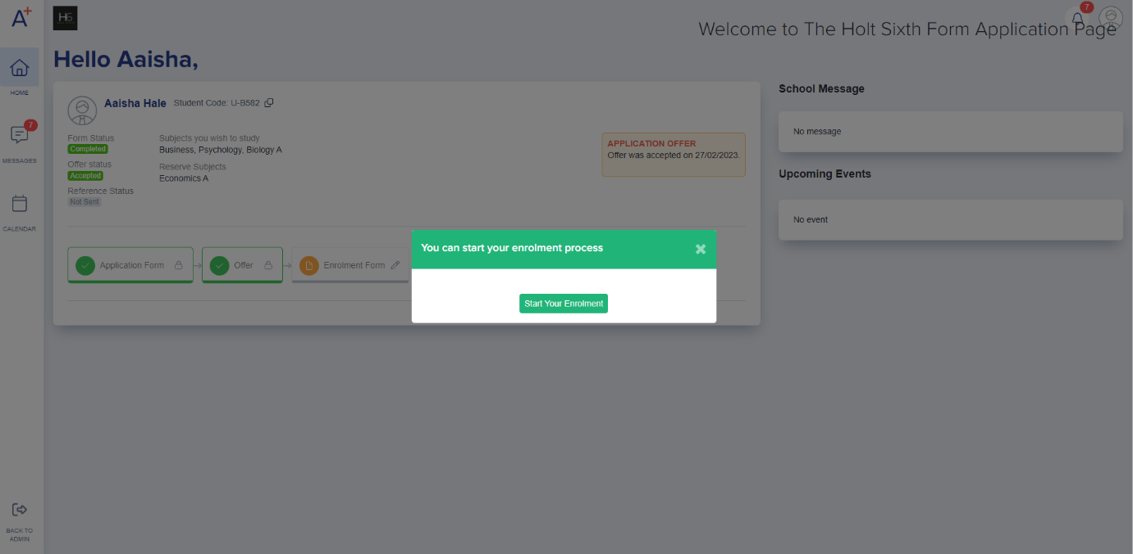

Step 2:

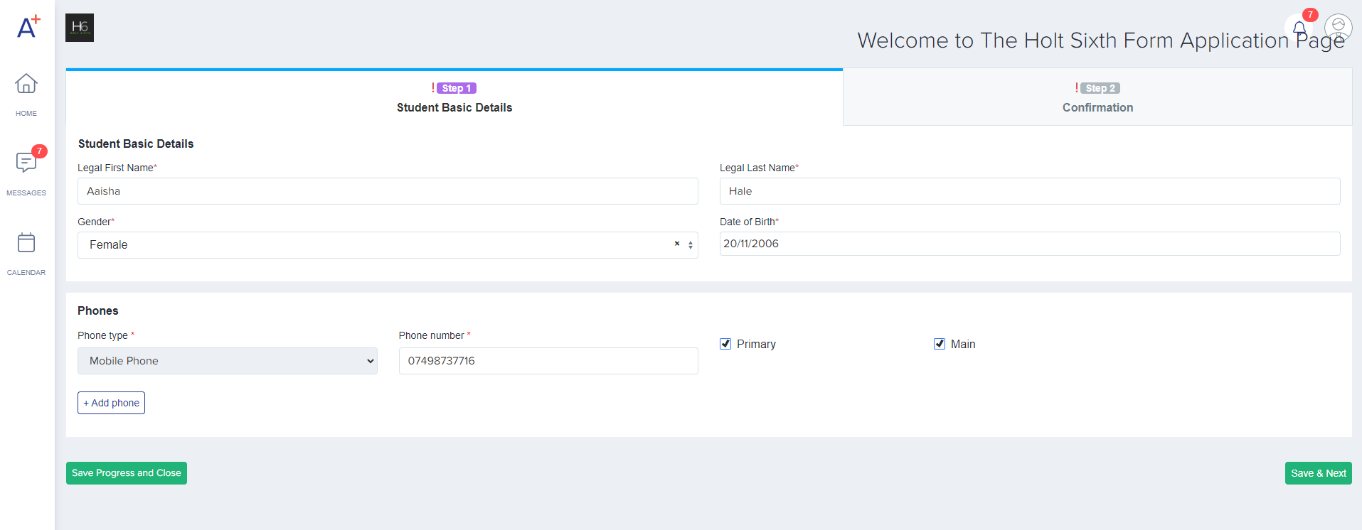
Confirm your personal details

Step 3:
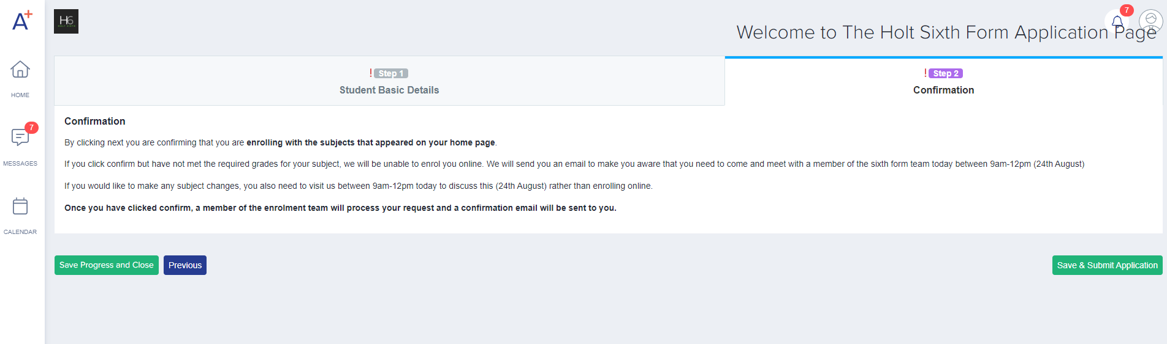
Confirm that you are enrolling with the correct subjects and that you have met the entry requirements for these subjects

Step 4:
Your enrolment form is sent to the enrolment team who will confirm all of your subjects, and you will receive an email confirmation once this is complete.
Please note:
- If you have not met the entry requirements and/or would like to change subject you must come in person to meet with the sixth form team in L5 in the languages block between 8:30am and 12pm.
- If you start the enrolment process online but haven’t met the grades, we will not be able to process your application any further, and will email you to remind you that you need to come in to see us

Notes for Internal Students:
- If you need to come in to meet with the sixth form team due to not meeting the entry requirements or subject changes please email enrolment@holt.wokingham.sch.uk from 8:30am to arrange a suitable time to speak to you on the phone or via Teams about your enrolment.
- If you have not yet put in an application form and have decided to apply on results day or you applied late, please come and visit us in L5 in the languages block to discuss your application between 1pm-3pm
- If you have any issues at all with enrolment, please email enrolment@holt.wokingham.sch.uk

