Welcome (almost) Year 12! It would be great if you took some time over the summer to start to get to know the course material and develop your background knowledge so that we can hit the ground running in September. Below are a range of books and things to watch to help you all tap into your love of history.
Miss Howard (h.howard@holt.wokingham.sch.uk) and Mrs Hagger (r.hagger@holt.wokingham.sch.uk)
Book Recommendations
To get the most out of your A Level, we will be suggesting you complete wider reading around topics. As a starting point, we recommend the following titles:
(remember, you can add these to your wider reading log in September!)
Core textbooks (you will need a copy of each of these….they cover the full A Level course)
I’ve included the Amazon link here for ease, but you may be able to source them cheaper elsewhere. A ‘used’ copy will do the trick and is much cheaper!
-M Tillbrook (2015), The Tudors: England 1485-1603
ISBN 978-0-19-835460-4
(https://www.amazon.co.uk/Oxford-AQA-History-Level-1485-1603/dp/0198354606/ref=sr_1_1?dchild=1&keywords=aqa+a+level+tudors&qid=1619765255&sr=8-1 )
-R Whitfield (2015), Democracy and Nazism: Germany 1918-1945
ISBN 978-0-19-835457-4
(https://www.amazon.co.uk/Oxford-AQA-History-Level-Democracy/dp/0198354576/ref=sr_1_1?dchild=1&keywords=democracy+and+nazismtextbook&qid=1619765211&sr=8-1 )

Further reading

The Tudors:
-A Anderson and T Imerato (2001) An Introduction to Tudor England 1485–
1603
-J. Guy Tudor England (2000)
-J. Guy (2000) The Tudors, a very short introduction
-G W Bernard (2007) The Kings Reformation: Henry VIII and the Remaking of
-the English Church
-D Cressy and L A Ferrell (2005) Religion and Society in Early Modern England
-C Culpin and E Evans et al (1997) Tudor Britain 1485–1603
-I Dawson (1993) The Tudor Century
Germany:
-M Burleigh, The Third Reich: A New History, Pan, 2001
-Sir I Kershaw, The 'Hitler Myth': Image and Reality in the Third Reich, Oxford
Paperbacks, 2001
-F McDonough, Opposition and Resistance in Nazi Germany (Cambridge Perspectives in History), Cambridge University Press, 2001
-A McElligott, Weimar Germany (Short Oxford History of Germany), OUP, 2009
- Rees, Auschwitz : The Nazis & The 'Final Solution’, BBC Books, 2005
- L Rees, The Nazis: A Warning From History, BBC Books, 2006
-A Weale, The SS: A New History, Abacus, 2012

Film/ Documentary Recommendations
There are a number of useful films and documentaries that will develop your wider understanding of the topics covered and give you a sense of period. Many of these suggestions are on Netflix.
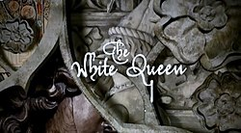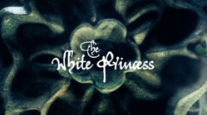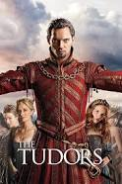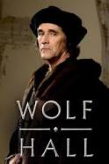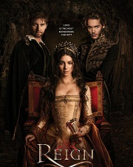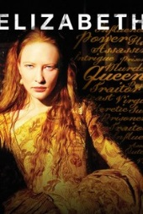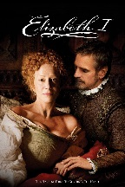

The Tudors:

- The White Queen and The White Princess (the former is more on the War of the Roses but the final couple of episodes will be good. The White Princess is a sequel and is good for Henry VII)
-Henry VIII (DVD) 2003
-P Gregory The Other Boleyn Girl
-The Tudors
-Wolf Hall
-The Shadow of the Tower (1972)- is good for Henry VII
-Reign (is more about Mary Queen of Scots, but gives excellent context for Year 13)
- Mary Queen of Scots film (most up to date research on her)
-Elizabeth (starring Cate Blanchett. Gives a good insight into Elizabeth’s psychology if not totally accurate)
-Elizabeth I (starring Helen Mirren. A good insight into many issues of her later reign)

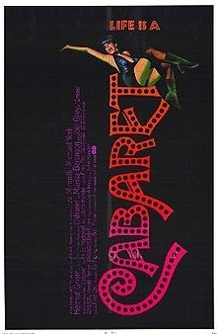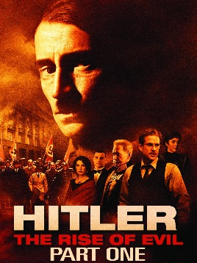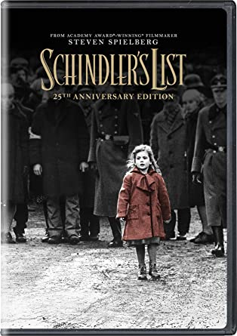

Germany:

-Auschwitz - The Nazis And The Final Solution, [DVD]
-Downfall (1 Disc Edition), [DVD]
-Hitler: The Rise of Evil, (2003), [DVD]
-Schindler's List - 20th Anniversary Edition, [DVD], [1993]
-The Nazis - A Warning From History, [DVD]
-The Relief Of Belsen, [DVD]

Research Activity
Using the internet and any books, complete the following task. You should produce notes using the Cornell Note Taking System (http://lsc.cornell.edu/wp-content/uploads/2015/10/Cornell-Note_Taking-System.pdf) on the following topic(s).
What happened at the Battle of Bosworth?
What happened at the Battle of Stoke Field 1487?
Why did the Kaiser flee from Germany in November 1918??
What happened during the Spartacist and Kapp putsches?

The above tasks are specific. Make a spider diagram of issues and events relating to
a) the reign of Henry VII 1485-1509
b) Weimar Germany 1918-1932

Pre-Knowledge Task
You could also use this time to get to know some key figures you’ll be studying on the A Level course.
Research and create a set of top trump/profile cards about the following historical figures:

Henry VII Sir Reginald Bray Lambert Simnel Perkin Warbeck
Empson & Dudley Henry VIII Thomas Wolsey Thomas Cromwell
Thomas Cranmer Catherine of Aragon Anne Boleyn

Freidreich Ebert Gustav Stresemann Adolf Hitler Rosa Luxemburg
Kurt von Schleicher Paul von Hindenburg Franz von Papen Wolfgang Kapp
Gregor Strasser

You should include information like: time in office/on the throne, how powerful they were (with a bullet point), how significant were they (with a bullet point), any special features (something distinctive about them)

Ideas for Day Trips
Visiting some of the places in the list below could be fun AND educational….
Hampton Court
Tower of London
Imperial War Museum (Holocaust exhibit)

Social Media and Websites
A who’s who of who to follow on social media…..
General history resources:
- In Our Time podcast (BBC Radio 4) – each episode covers a particular topic and academics debate key issues
- Greg Jenner’s ‘You’re Dead To Me’ podcast – a bit of fun, but interesting!
- Dan Snow’s History HIT – there’s a podcast but also YouTube videos on a range of topics
Germany:

http://spartacus-educational.com/GERweimar.htm
http://weimarandnazigermany.co.uk/5-top-sites-find-primary-documents-weimar-germany
http://www.historylearningsite.co.uk/weimar_germany.htm
http://www.historylearningsite.co.uk/Nazi%20Germany.htm
http://www.ushmm.org/research/research-in-collections/search-the-collections/bibliography/primary-sources
http://www.calvin.edu/academic/cas/gpa/
http://lagrange.campusguides.com/content.php?pid=375607&sid=3076488
http://www.besthistorysites.net/index.php/modern-history/hitler

Tudors:

www.johnguy.co.uk
www.history.ac.uk
www.activehistory.co.uk
www.bbc.co.uk/history
www.tudorplace.com

