Book Recommendations
Useful books to give an overview of general music studies and topics useful for A level. You are not expected to buy these as some are very expensive, but they might be of interest for wider reading if you can find them in libraries.
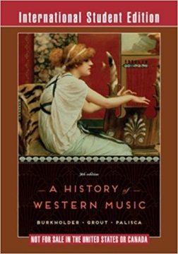

‘A History of Western Music’- Very expensive to buy but has a great overview of music over the last 1000 years.

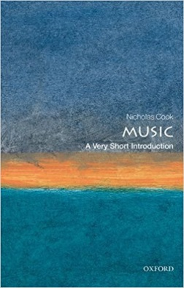
‘A very short introduction to Music’- Nicholas Cook.
A short and affordable book which introduces the idea of ‘Music’ in its widest possible sense and is really interesting for exploring the reasons that we choose to study music at A level and beyond.

Wider listening preparation
It is important to come prepared with a general understanding of the styles and set works for A level, as there is a lot of music to get to grips with. As a starting point, make sure you listen to/watch the following pieces of music.
Essential listening:

Topic: Jazz Music
Listen to at least two pieces from the following artists to get an understanding for their style:
- Louis Armstrong
- Duke Ellington
- Charlie Parker
- Miles Davis
- Pat Metheny
- Gwilym Simcock

Topic: The piano music of Chopin, Brahms and Grieg.
- Ballade no.2 in F major, Chopin
- Nocturne in E minor op.72 no.1, Chopin
- Intermezzo in A major op.118 no.2, Brahms
- Ballade in G minor op.54 no.2, Brahms
- Norwegian march op.54 no.2, Grieg
- Notturno op.54 no.4, Grieg.

When listening to this music, it is often useful to take a note of what you’ve listened to and jot down anything you find interesting/unusual or anything you particularly like or dislike about the music. This will help you remember it and help to discuss it when we come to studying the pieces throughout the year.

Optional extra listening

Topic: The operas of Mozart
- Le Nozze di Figaro (The Marriage of Figaro) Act 1. Various versions are available on youtube, a complete production can be found: https://www.youtube.com/watch?v=x8OHbbmfnW8

Topic: Baroque solo concerto
- Sonata for trumpet and strings in D major Z.850, Purcell
- Flute concerto in D ‘Il Gardellino’ Op.10 No.3 RV428, Vivaldi
- Violin concerto in A minor BWV1041, Bach

It is crucial to listen to a range of music that you wouldn’t usually listen to. The A level course is designed to broaden your horizons, and to introduce you to new music which you will appreciate and enjoy.

Preparation tasks for Year 12
Theory
It is important to have a solid grounding in theory knowledge when starting the course. It would be a good idea to be working towards Grade 5 theory (if not already taken), as this will help with a number of aspects of the course. We will cover a range of music theory throughout the two years but you should be confident in the following areas:
Musical notation- Confident in reading notation from both Treble and Bass clef.
Key signatures- Clear understanding of how to work out key signatures (major and minor) and be able to recognise key signatures up to 4 sharps and flats.
Musical vocabulary- A good understanding of general vocabulary to describe: Texture, Tempo, Dynamics, Rhythm, Structure, Melody, Harmony, Tonality etc.

Musical styles/genres
It is important to have a good understanding of the key features of different styles and genres of music.
For each of the genres of music below, prepare a detailed list of the musical features of the style. Listen to one piece from each style (you can choose anything) and describe how it is typical of that style.

- Baroque
- Classical
- Romantic
- Jazz
- Pop

Please bring this to our first lesson. This will form the core foundation to your understanding of the styles, and you will be able to add to it throughout the year.

Extra resources
BBC Radio 3 Podcasts:

Composer of the week: http://www.bbc.co.uk/programmes/articles/3cjHdZlXwL7W41XGB77X3S0/composers-a-to-z

There are a huge number of programmes introducing different composers and their compositions. The link gives an extensive index of all the programmes available. The podcasts are really interesting giving contextual information alongside relevant musical extracts.

BBC podcasts on Jazz Music:

http://www.bbc.co.uk/programmes/genres/music/jazzandblues/jazz/all

