Welcome to Philosophy and Ethics. We are so excited that you are joining us next year to study this course. Over the summer it would be useful to look at the some of the books and films below to get a feel of the course and start to foster an interest in the subject.
Mrs Barker (e.barker@holt.wokingham.sch.uk ) and Mrs Pettet (who will be joining us in September)

Recommendations
To get the most out of your A Level, we will be suggesting you complete wider reading around topics. The topics will study are vast so as a starting point, we recommend the following titles:

Core textbooks
You will need a copy of the 3 textbooks below. If you look on Amazon, there are often second-hand copies available.

Philosophy - OCR A Level Religious Studies: Philosophy of Religion: Amazon.co.uk: Waterfield, Julian, Eyre, Chris, Dean, Karen: 9781510479937: Books

Ethics - OCR A Level Religious Studies: Religion and Ethics: Amazon.co.uk: Waterfield, Julian, Eyre, Chris, Dean, Karen: 9781510479951: Books

Buddhism - My Revision Notes: A-level Religious Studies Buddhism: Amazon.co.uk: Houghton-Knight, Richard: 9781398317178: Books

Further reading (these will be available in the department for reference)

An Introduction to Buddhism, Second Edition: Teachings, History and Practices (Introduction to Religion) : Harvey, Peter: Amazon.co.uk: Books

What the Buddha Taught: Written by Walpola Rahula, 2000 Edition, (Rev Ed) Publisher: Atlantic Books [Paperback]: Amazon.co.uk: Walpola Rahula: 8601417206157: Books

Fiction is often a good place to start with new knowledge and information. Below are recommendations for films, documentaries, and books you could look at over the holidays and beyond!

Books (Make use of your local library)

Philosophy
- "Sophie's World" by Jostein Gaarder
Themes: History of philosophy, philosophical concepts.

- "1984" by George Orwell
Themes: Totalitarianism, free will, and reality.

- "Brave New World" by Aldous Huxley
Themes: Utopian society, utilitarianism, and individual freedom.

- "The Stranger" by Albert Camus
Themes: Absurdism, existentialism, and meaning.

- "Crime and Punishment" by Fyodor Dostoevsky
Themes: Morality, guilt, and redemption.

- “The Brothers Karamazov" by Fyodor Dostoevsky
Themes: Free will, faith, and morality

- "Lord of the Flies" by William Golding
Themes: Human nature, civilization vs. savagery, and morality.

Ethics

- "To Kill a Mockingbird" by Harper Lee
Themes: Justice, morality, and racial inequality.

- "The Handmaid's Tale" by Margaret Atwood
Themes: Autonomy, oppression, and gender ethics.

- "Animal Farm" by George Orwell
Themes: Power, corruption, and ethical leadership.

- "Frankenstein" by Mary Shelley
Themes: Creation, responsibility, and ethical science.

- "The Picture of Dorian Gray" by Oscar Wilde
Themes: Hedonism, morality, and the consequences of ethical choices.

- "The Kite Runner" by Khaled Hosseini
Themes: Redemption, guilt, and moral responsibility.

Buddhism

- "Siddhartha" by Hermann Hesse
Themes: Spiritual journey, enlightenment, and self-discovery.

- "The Buddha in the Attic" by Julie Otsuka
Themes: Suffering, resilience, and community.

- "The Snow Leopard" by Peter Matthiessen
Themes: Pilgrimage, nature, and spirituality.

- "Jitterbug Perfume" by Tom Robbins
Themes: Immortality, reincarnation, and the search for meaning.

- "Breakfast with Buddha" by Roland Merullo
Themes: Spiritual awakening, mindfulness, and transformation.

Film/ Documentary Recommendations
There are many useful films and documentaries that will develop your wider understanding of the topics covered and give you a flavour of the topics. Many of them will be available on streaming platforms.
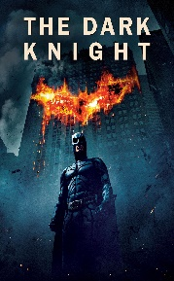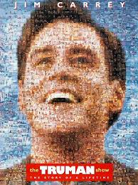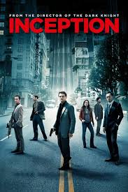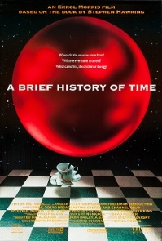

Philosophy of Religion
- The Matrix (1999)
Philosophical Themes: Reality vs. illusion, scepticism, and metaphysics.
- Inception (2010)
Philosophical Themes: Reality and dreams, the nature of consciousness, and personal identity.
- Blade Runner (1982) / Blade Runner 2049 (2017)
Philosophical Themes: Artificial intelligence, what it means to be human, ethics.
- The Truman Show (1998)
Philosophical Themes: Free will vs. determinism, reality, and authenticity.

Documentaries
- A Brief History of Time (1991)
Philosophical Themes: Cosmology, the nature of the universe.
- Human, All Too Human (1999)
Philosophical Themes: Biography of Friedrich Nietzsche, Martin Heidegger, and Jean-Paul Sartre.

Ethics
Films
- GATTACA (1997)
Ethical Themes: Genetic engineering, eugenics, and discrimination.
- Schindler's List (1993)
Ethical Themes: The Holocaust, moral courage, and altruism.
- The Dark Knight (2008)
Ethical Themes: Vigilantism, moral ambiguity, and justice.
- A Few Good Men (1992)
Ethical Themes: Military ethics, duty, and moral responsibility.
- Dead Man Walking (1995)
Ethical Themes: Capital punishment, forgiveness, and redemption.
- Hotel Rwanda (2004)
Ethical Themes: Genocide, moral responsibility, and humanitarian intervention.
- Million Dollar Baby (2004)
Ethical Themes: Euthanasia, autonomy, and the value of life.
Documentaries
- Super-Size Me (2004)

Ethical Themes: Corporate responsibility, health, and consumer rights.
- Earthlings (2005)
Ethical Themes: Animal rights, veganism, and speciesism.

Buddhism

Films
- Kundun (1997)
Themes: Life of the 14th Dalai Lama, Tibetan Buddhism, and Chinese occupation.
- Little Buddha (1993)
Themes: Life of Siddhartha Gautama, the search for enlightenment.
- Samsara (2001)
Themes: Monastic life, worldly desires, and the quest for enlightenment.
- Seven Years in Tibet (1997)
Themes: Tibetan Buddhism, the life of the Dalai Lama, and cultural exchange

Documentaries
- The Buddha (2010)
Themes: Life of Siddhartha Gautama, core Buddhist teachings.
- Dalai Lama: Scientist (2019)
Themes: Intersection of Buddhism and science, the Dalai Lama’s interest in scientific inquiry.
- The Dhamma Brothers (2007)
Themes: Vipassana meditation, rehabilitation, and transformation in a prison setting.

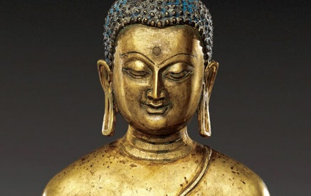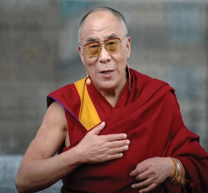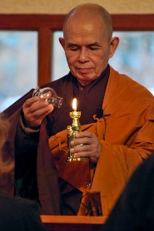

Research Activity

We will be meeting lots of new ‘Characters’ when we start the course, and it would be good to get a feel of Who’s who.

Create a fact file for the following – Who are they, what are their main ideas, do they link to anyone else that we will be studying?

Philosophy
Plato
Aristotle
Descartes

Ethics
Aquinas
Joesph Fletcher
Kant

Buddhism
The Buddha
14th Dalai Lama
Thich Nhat Hanh

Ideas for Day Trips

Philosophy and Ethics

Oxford
- University of Oxford: Home to one of the world's leading philosophy departments. Students can visit the Bodleian Library, the Ashmolean Museum, and attend public lectures or events if available.
- Pitt Rivers Museum: Offers insights into various cultures, which can enhance understanding of moral relativism and cultural ethics.

Cambridge
- University of Cambridge: Another prestigious university with a rich history in philosophical thought. The Wren Library at Trinity College houses works by notable philosophers like Bertrand Russell and Ludwig Wittgenstein.
- The Fitzwilliam Museum: Contains collections that explore human culture and art, providing a backdrop for discussions on aesthetics and ethics.

London
- The British Museum: Offers extensive collections that can help contextualize discussions on ethics, human rights, and cultural heritage.
- The British Library: Hosts a wide range of philosophical texts and manuscripts, including works by Jeremy Bentham and John Stuart Mill.
- The Wellcome Collection: Explores the connections between medicine, life, and art, useful for bioethics discussions.

Buddhism
- The British Museum: Houses an extensive collection of Buddhist art and artifacts from various Buddhist traditions around the world.
- The Buddhist Society: Founded in 1924, it's one of the oldest Buddhist organizations outside Asia, offering talks, courses, and events.
- London Buddhist Centre: Offers meditation classes, talks, and workshops on Buddhism in a modern urban setting.

