Hi there,

I am delighted that you are thinking of studying A level Physical Education in September. The step up from GCSE work to A level can be tough and many students must adjust to the increased demands of workload, independence and responsibility. At the same time, students get the opportunity to study the subjects that they have been most interested in or are now shaping their pathway into University or apprenticeships. In order to give yourself the best start in Autumn with your new course, we suggest that you complete the following preparation tasks to the best of your ability.

Before you start the preparation tasks . . . perhaps you might like to know a bit about A level PE at The Holt:

##### The Course

At our Sixth Form we follow the OCR course. The course is suited to students who have a genuine interest in sporting excellence and the science behind it. The two-year course covers 7 theoretical units per year and 1 personal sporting performance. Units include Anatomy and Physiology, Exercise Physiology, Biomechanics, Sports Psychology, and Skill Acquisition.

The course is 70% theory and 30% practical over the two years. The course is demanding both practically and theoretically therefore students must be competitively taking part in a sport/activity outside of sixth form.

##### Non examined assessment. (Your practical assessment and coursework)

The non-examined assessment makes up 30% of the course. Students will need to be assessed in one practical sport and will be required to collect video evidence during the two-year course.

Here is a link to the specification for the non-examined assessment, should you wish to look into this further:

<https://www.ocr.org.uk/Images/234840-as-and-a-level-guide-to-non-exam-assessment.pdf>

# Transition work

#### Applied anatomy and Physiology

This first task is to recap the basics for anatomy and physiology, you will have covered these two systems as part of your GCSE work and this is a good starting point before we look at these in more depth in Autumn.

**Task –** Please create a PowerPoint detailing the effects and benefits of long-term exercise on the body systems. Please use the following as guidance for what we are looking for.

Musculoskeletal System

* Bone density
* Ligaments and tendons
* Muscular hypertrophy
* Rest for adaptions and recovery

Cardio-respiratory System

* Resting heart rate
* Recovery time
* Resting stroke volume
* Cardiac output
* size and strength of heart
* Number of blood cells
* Resting blood pressure
* Lung capacity/volume and vital capacity
* Number of alveoli
* Strength of diaphragm and intercostal muscles

## Exercise Physiology

##### Diet and Nutrition and their effect of physical performance

Diet and Nutrition Healthy, balanced diet

Diet and nutrition are topics that you will have looked at within GCSE PE and Science. Firstly, lets revisit what you should already know.

For 19-50 year olds, what is the government recommendation for the following calorie guidelines?

* Men calories per day
* Female calories per day

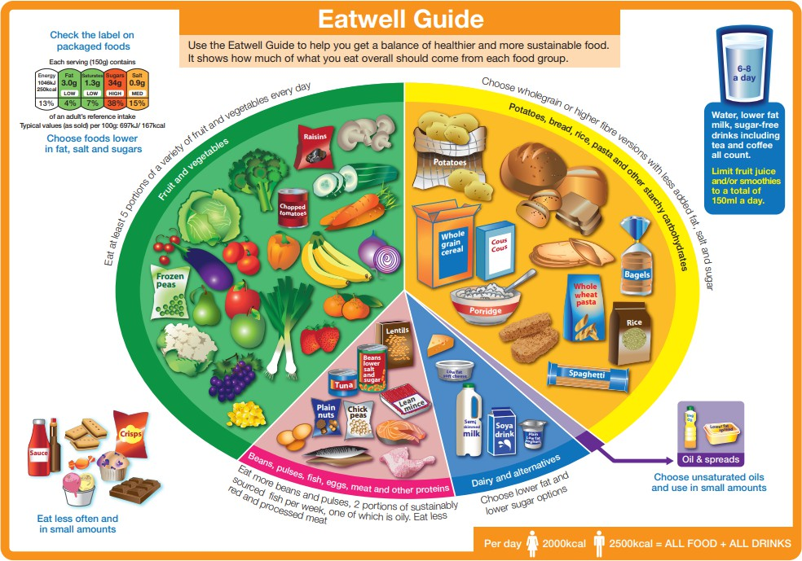

You should also be familiar with the three macronutrients of carbohydrates, proteins and fats. Now let’s look at them in a little more detail.

##### Carbohydrates (CHOs)

**CHOs** are vital for energy production. They are the preferred fuel for exercise, accounting for approximately 75% of the energy requirements. CHOs can be consumed (eaten/drunk) in several forms for example, starches and sugars. Please complete the table below.

|  |  |  |
| --- | --- | --- |
| Carbohydrate | Example food (what can you eat that contains this type of CHO) | Where are they stored in the body? |
| Starches |  |  |
| Sugars |  |  |

##### Proteins

Proteins (found in milk eggs, meat and soya) are essential for:

* Growth and repair of tissues and cells
* Making muscle proteins (increasing muscle size)
* Making Haemoglobin
* Making enzymes, antibodies and collagen

##### Fats

Role of fats:

* Insulate nerves, form cell membranes and cushion organs
* Provide an energy store – they can be broken down for aerobic energy production and have twice the yield of CHOs

*Research Question*– what is the difference between saturated fat and unsaturated fat?

. . . . . . . . . . . . . . . . . . . . . . . . . . . . . . . . . . . . .

. . . . . . . . . . . . . . . . . . . . . . . . . . . . . . . . . . . . .

. . . . . . . . . . . . . . . . . . . . . . . . . . . . . . . . . . . . .

. . . . . . . . . . . . . . . . . . . . . . . . . . . . . . . . . . . . .

|  |  |  |
| --- | --- | --- |
| Fat Type | Food Example | Consideration |
| Unsaturated fatty acids |  | Can boost the delivery of oxygen, improve endurance recovery, and reduce joint inflammation |
| Saturated fatty acids |  | Limit intake to reduce the risk of cardiovascular |

### Ergogenic aids

An ergogenic aid is a substance, object or method used to improve or enhance performance. A pharmacological aid is a group of ergogenic aids taken to increase the levels of hormones or neural transmitters. A physiological aid is a group of ergogenic aids used to increase the rate of adaptation of the body to increase performance.

**Pharmacological aids:** (Anabolic steroids, Erythropoietin (EPO), Human Growth hormone)

##### Physiological Aids:

Please complete the table below. Outline to benefits, draws and practical applications of physiological aids.

|  |  |  |  |  |
| --- | --- | --- | --- | --- |
| *Physiological aid* | *Legal or illegal* | *+ Benefits* | *-Drawbacks* | *Type of athlete likely to use this aid* |
| **Blood doping**   * Red blood cell volume is increased * Removed blood 4-6 weeks before * Body compensates, replenishing lost RBCs |  |  |  |  |
| **Intermittent**  **hypoxic training (IHT)**  Athletes live at sea level but train under hypoxic conditions) |  |  |  |  |
| **Cooling aids**   * Pre-event: ice vests, cold towel wraps – used 10-30 mins before to reduce core body temperature * Injury: Ice packs, sprays, PRICE (protect, rest, ice, compression,   elevate) |  |  |  |  |

|  |  |  |  |  |
| --- | --- | --- | --- | --- |
| * Post event: ice baths |  |  |  |  |

### Supplementation

Supplements can also be used to improve and enhance performance. You may already be aware (or know people) who used creatine or who include caffeine as part of their diet. Please complete the table below to outline the benefits, drawbacks, and practical application of supplementation.

|  |  |  |  |  |
| --- | --- | --- | --- | --- |
| Dietary Supplementation | *Legal or illegal* | *+ Benefits* | *-Drawbacks* | *Type of athlete likely to use this aid* |
| **Creatine**  Taking supplement in the form of powder/tablet to increase phosphocreatine (PC) stories in muscle: used for very high intensity energy production |  |  |  |  |
| **Caffeine**  Stimulates CND and increases breakdown of FFAs for aerobic energy production |  |  |  |  |
| **Bicarbonate**  Alkaline which acts as a buffer to neutralise a rise in acidity in the blood stream |  |  |  |  |

### Injuries

Injuries is another topic taught in the GCSE PE specification. Within A level Physical Education, we look at injuries in much greater depth, as unfortunately it is near impossible to come across a sports performer who have never experienced some form of injury!

For this task you can decide how you would like to present your work. Choose a method which suits you but shows your research into:

* Definition: Acute vs chronic injuries
* Acute: Hard tissue injuries – Fracture & Dislocation
* Acute: Soft Tissue injuries: Contusion and Haematoma,

Sprain & Abrasion

* Chronic Injuries: Stress fracture, Shin Splints, Tendinosis

## Exercise Psychology

These next few tasks will help you for the Sports Psychology unit. Sport psychology is the study of how psychology influences sports, athletic performance, exercise, and physical activity. Some [sports](https://www.verywellmind.com/what-is-a-sport-psychologist-3120695) [psychologists](https://www.verywellmind.com/what-is-a-sport-psychologist-3120695) work with professional athletes and coaches to improve performance and increase motivation. Other professionals utilise exercise and sports to enhance people’s lives and well-being throughout the entire lifespan.

Professional sports psychologists often help athletes cope with the intense pressure that comes from competition and overcome problems with focus and motivation. They also work with athletes to improve performance and recover from injuries. But sports psychologists do not just work with elite and professional athletes. They also help regular people learn how to enjoy sports and learn to stick to an exercise program

**Tasks:**

**Personality**:

Think of 4 words that you would use to describe your personality. Then, if you can, ask the people you live with to also describe your personality in just 4 words (this can often be a difficult task for people to do)

When you have done this, please research the following personality types:



Once you have done this and wrote down a suitable description, can you find the science behind why someone is believed to be an introvert/extrovert. HINT – it is to do with something called the reticular activating system (RAS).

Now look back at your four words and the words given to you by your family members. Would you class yourself as being a Type A/B personality and are you more likely to be introverted/extroverted? Please write up your findings.

### Aggression

Task – Define Assertion and Aggression

There are currently four theories that try to explain why sports performers show aggressive behaviour in sport. For each of the theories create a PowerPoint slide to try to explain each. Try using google and YouTube to get the information that you need.

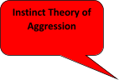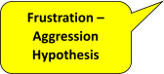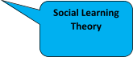

### Motivation & Arousal

First task – define both motivation and arousal.

Second task – find out what classifies as intrinsic motivation and extrinsic motivation. Then create a list of as many motivators as you can for two professional athletes and identify if they are intrinsic/extrinsic.

Task three -As a performer’s arousal increases, the state of readiness and expectation increases, but if the arousal gets too high, a performer can lose concentration and feel over-arousal. It is essential to understand three theories that try to explain how arousal affects performance. Research please, into the three graphs/theories of arousal and display your knowledge. These are:

* Drive Theory
* Inverted U Theory
* Catastrophe Theory

If you are struggling, get onto YouTube to get a basic understanding of this topic which will then help you to understand the theories.

# Socio-cultural issues in physical activity and sport

The section we are looking at here comes under the **Sport & Society** section.

***The Modern Olympic Games***

Task 1 - research the background of The Modern Olympic Games (1896) Discuss the aims of the Games

Discuss the philosophy behind why they were reintroduced

Guidance - Research the work carried out Baron Pierre de Coubertin and William Penny Brookes.

Task 2 - Research the political exploitation of the Olympic Games

* Berlin 1936, Third Reich Ideology
* Mexico City 1968 ‘Black Power’ demonstration
* Munich 1972 Palestinian terrorism
* Moscow 1980 boycott lead by USA
* Los Angeles 1984 boycott by Soviet Union

Explain how countries tried to use the Olympic Games as a tool to promote their political ideology. I am happy for this to be done as a research project on word or as a PowerPoint presentation. Add as much detail as you possibly can. Please discuss in detail the Nations and people involved, the rationale behind what happened and the legacy of the actions that occurred.

### Sport and Society

#### Ethics and Deviance in Sport – Doping and drugs in sport

Performance Enhancing Drugs is a topic that you should be familiar with from GCSE PE. Doping and drugs in sport is a topic studied in both the Physiology and Contemporary Issues units of A level PE.

Task 1 Video – If you have Netflix take a look at the following documentary – Icarus (2017). (Possibly also available to watch via Youtube)

Icarus 2017 - When filmmaker Bryan Fogel sets out to uncover the truth about doping in sports, a chance meeting with a Russian scientist transforms his story from a personal experiment into a geopolitical thriller. Dirty urine, unexplained death and Olympic gold are all part of the exposure of the biggest scandal in sports history.

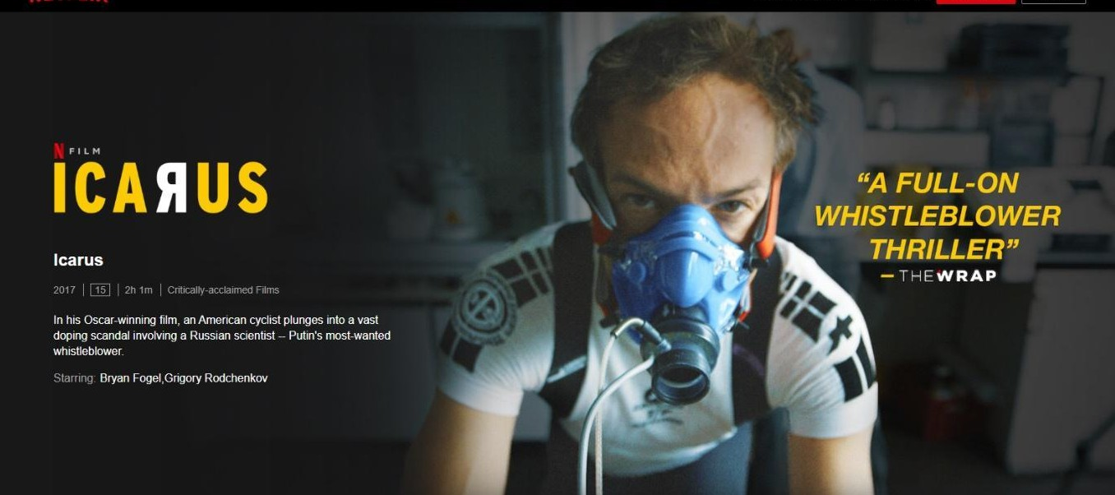

##### Task 2 – Reasons why elite performers use doping and illegal drugs

It is thought that some elite performers use doping and illegal drugs because of:

* + Pressure from coaches
  + Political Pressures
  + High monetary rewards for winning and lucrative sponsorship deals
  + Some performers think ‘everyone else is doing it’

Have a look at the following sports performers who have tested positive for banned substances. Create a brief information case study for each performer based upon your findings. Include:

* + Who is the performer/elite? What is their sport? Nationality? Age?
  + What did each performer test positive for?
  + What are the benefits of that drugs?
  + Any information for why they felt they needed to use banned substances
  + Any punishments put into place following their positive testing?

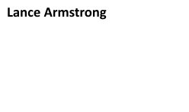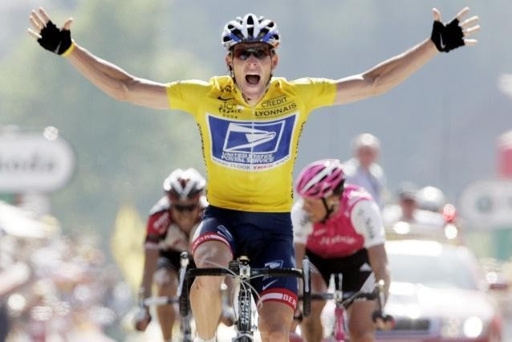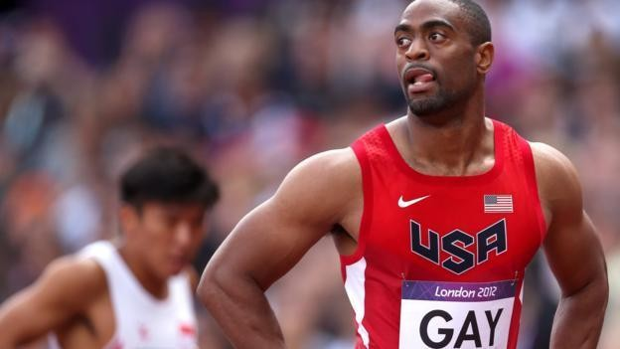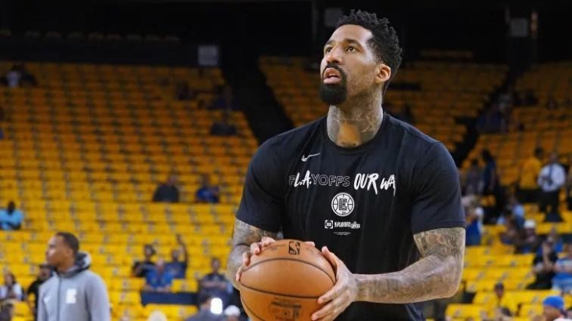

#### Final Task – Strategies to stop the use of doping and illegal drugs

Have a good look at the World Anti-Doping Agency website <https://www.wada-ama.org/en/who-we-are>.

Have a go at the ‘PlayTrue Quiz’ and see how much you already know about the work being done to try and keep sport ‘Drug Free’.

<https://www.wada-ama.org/en/what-we-do/education-prevention>