The following is a wide range of resources; choose to do any of the items you would like or that interest you. There is a lot to choose from: - Reading, Films or documentaries to watch, a Research Activity, a Pre-Knowledge Task, Websites to visit, a Design project to complete and when the lockdown is lifted and we can venture out and the shops and museums are open some places to visit, the choice is yours. Any of this will keep your Design brain going and ready to start you’re A’ Level Product design course.
Book Recommendations
It is vital that you are accustomed to completing wider reading around topics you will cover during your A levels. As a starting point, we recommend the following titles:
(There are a lot of titles here choose a few to start with, most of these will be in the department library for September)
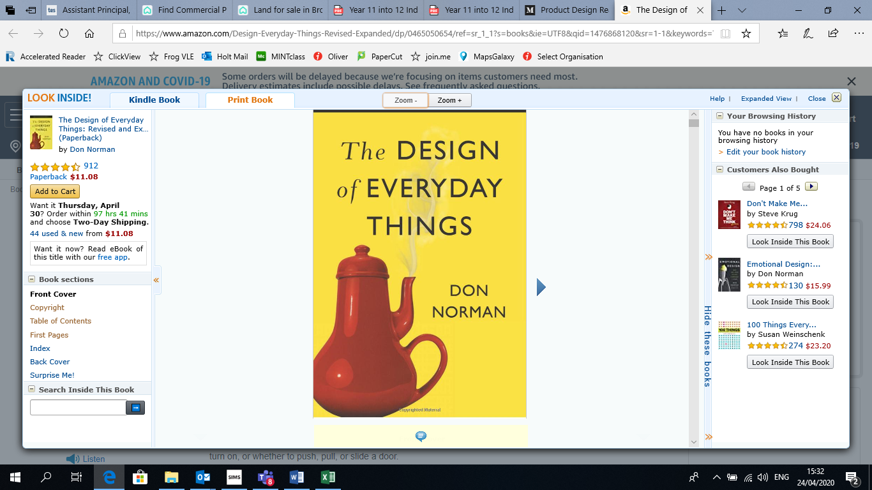
The Design of Everyday Things: by Don Norman
Even the smartest among us can feel inept as we fail to figure out which light switch or oven burner to turn on, or whether to push, pull, or slide a door. The fault, argues this ingenious -- even liberating -- book, lies not in ourselves, but in product design that ignores the needs of users and the principles of cognitive psychology. The problems range from ambiguous and hidden controls to arbitrary relationships between controls and functions, coupled with a lack of feedback or other assistance and unreasonable demands on memorization.

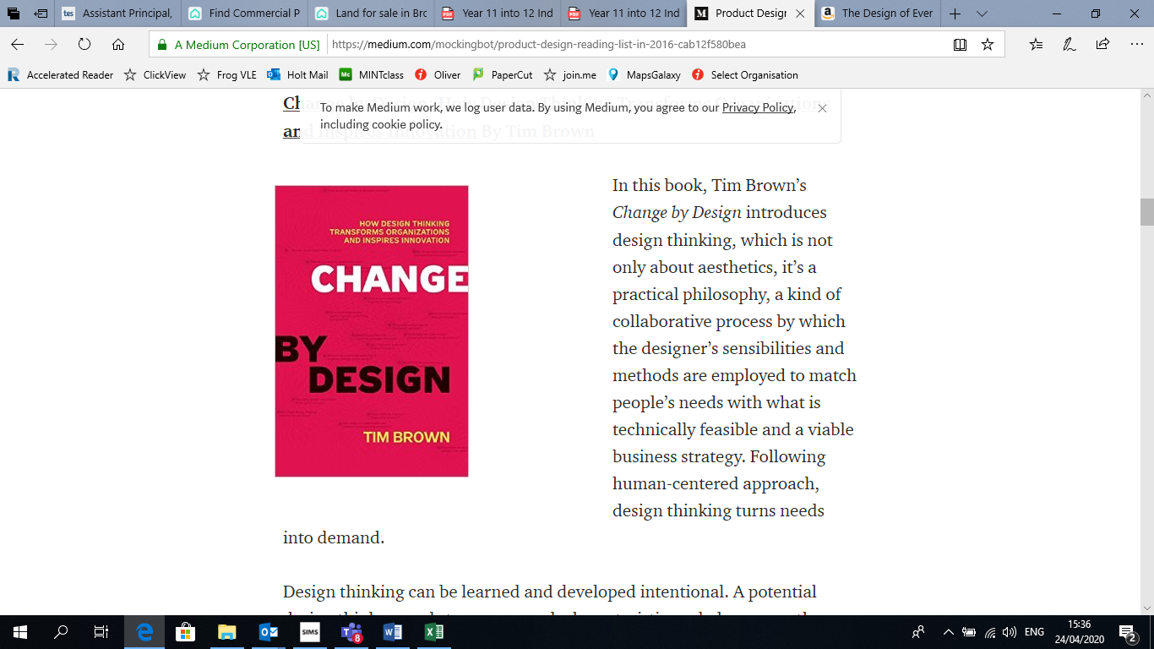
Change by Design – Tim Brown
Design thinking can be learned and developed intentional. A potential design thinker needs to possess such characteristics as below: empathy, integrative thinking, optimism, experimentalism and collaboration.

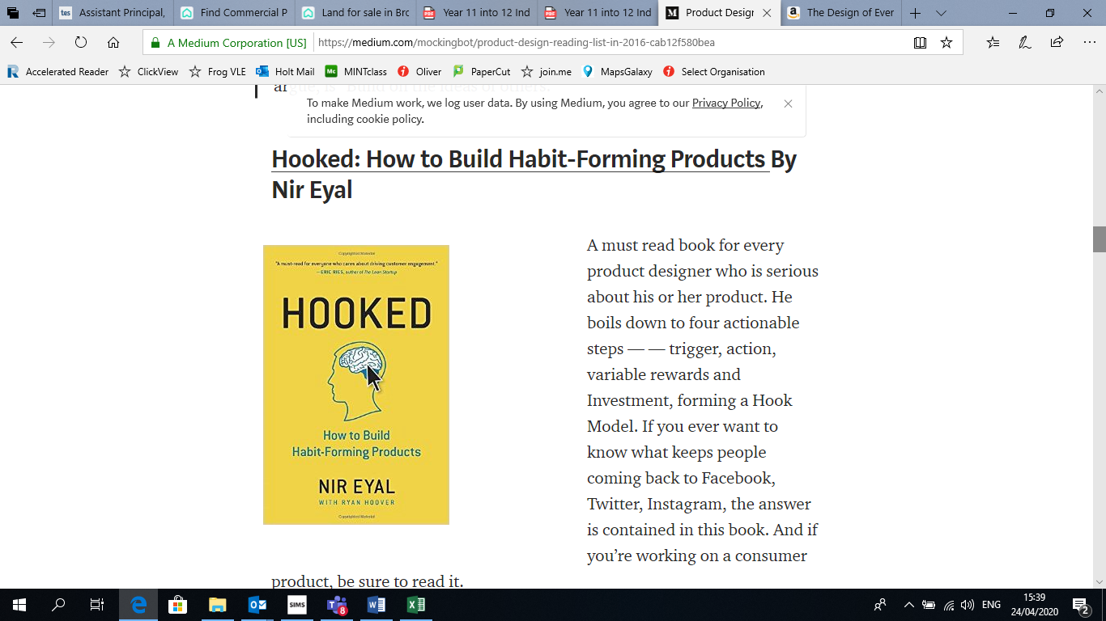
Hooked how to build Habit forming Products- Nir Eyal
A must read book for every product designer who is serious about his or her product. He boils down to four actionable steps — — trigger, action, variable rewards and Investment, forming a Hook Model. If you ever want to know what keeps people coming back to Facebook, Twitter, Instagram, the answer is contained in this book. And if you’re working on a consumer product, be sure to read it.

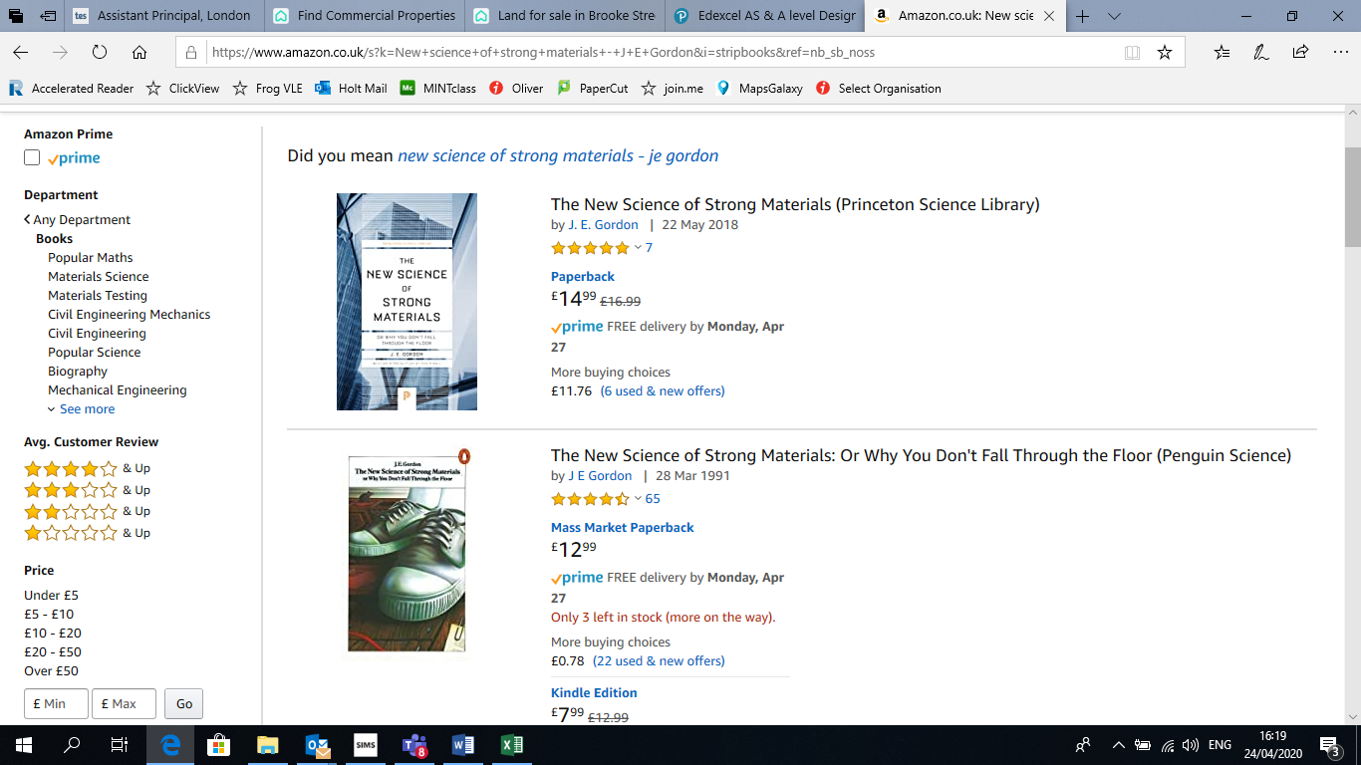
The New Science of Strong Materials or Why we don’t fall through the floor (2018)- J E Gordon

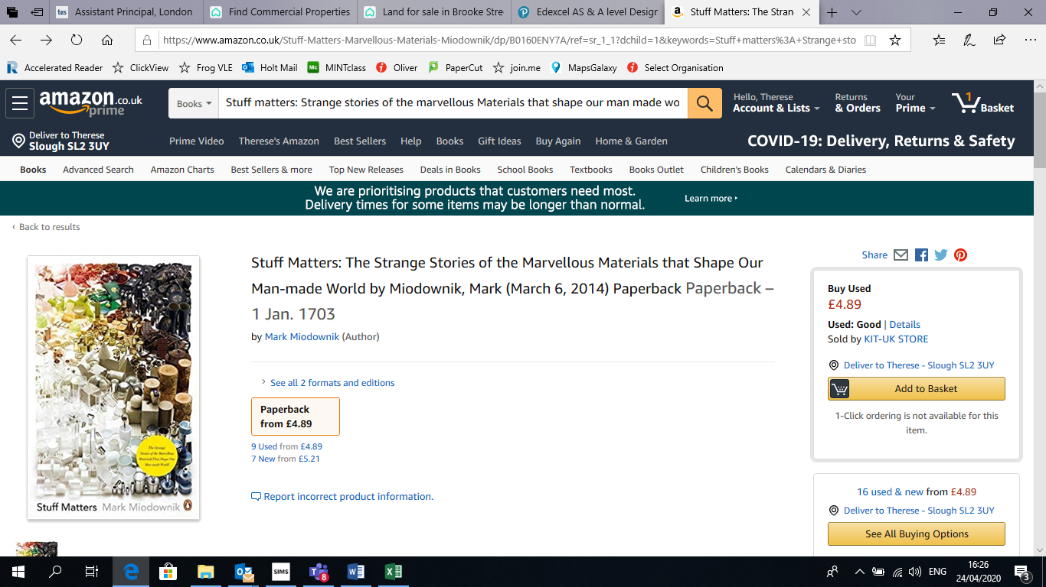
Stuff matters: Strange stories of the marvellous Materials that shape our man made world (2014) Mark Miodownik

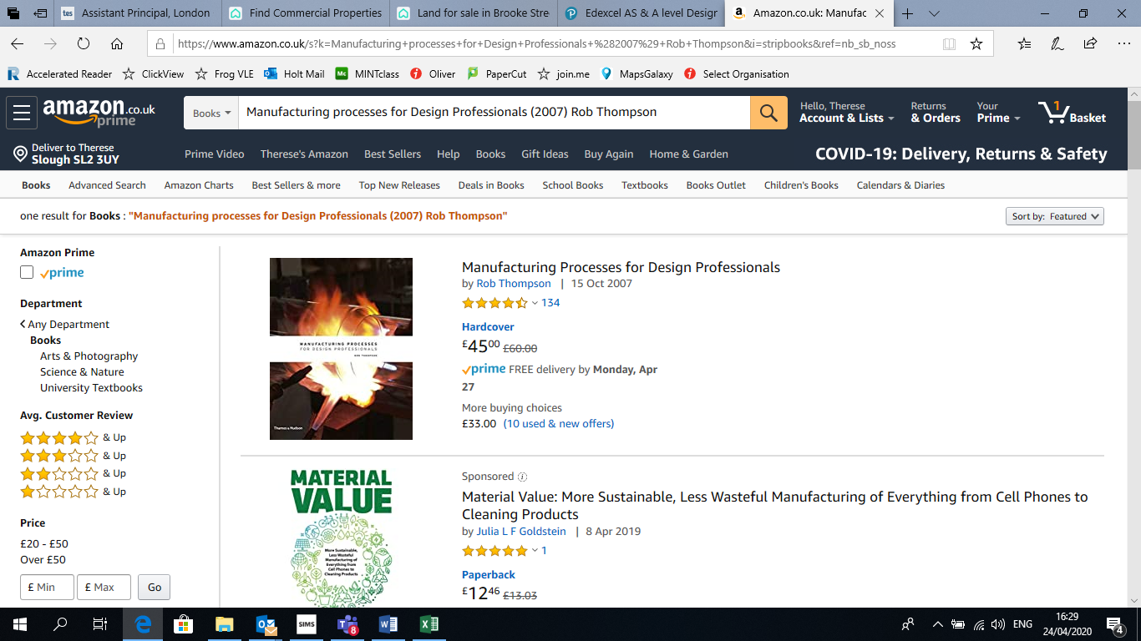
Manufacturing processes for Design Professionals (2007) Rob Thompson

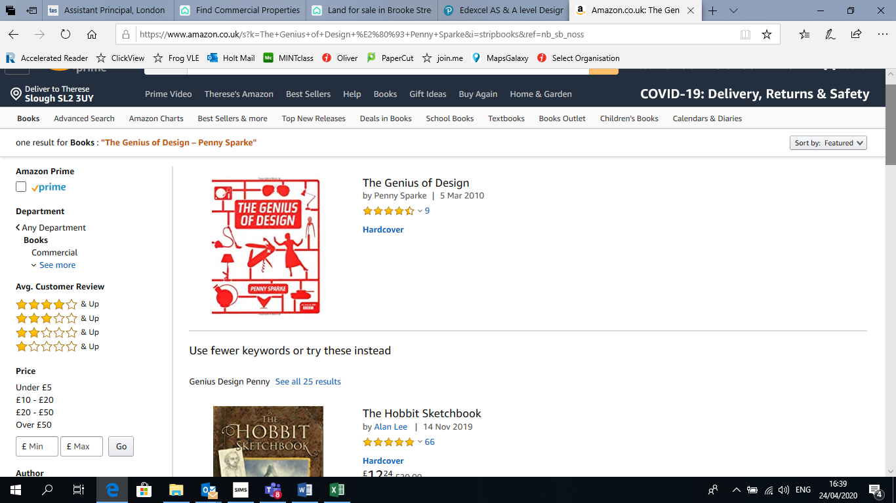
The Genius of Design – Penny Sparke

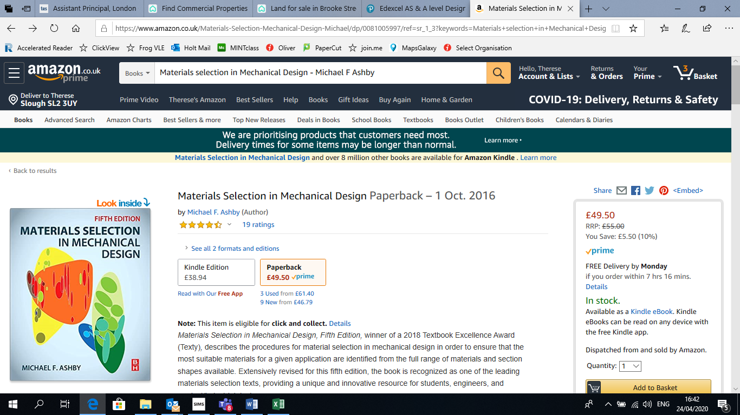
Materials selection in Mechanical Design - Michael F Ashby

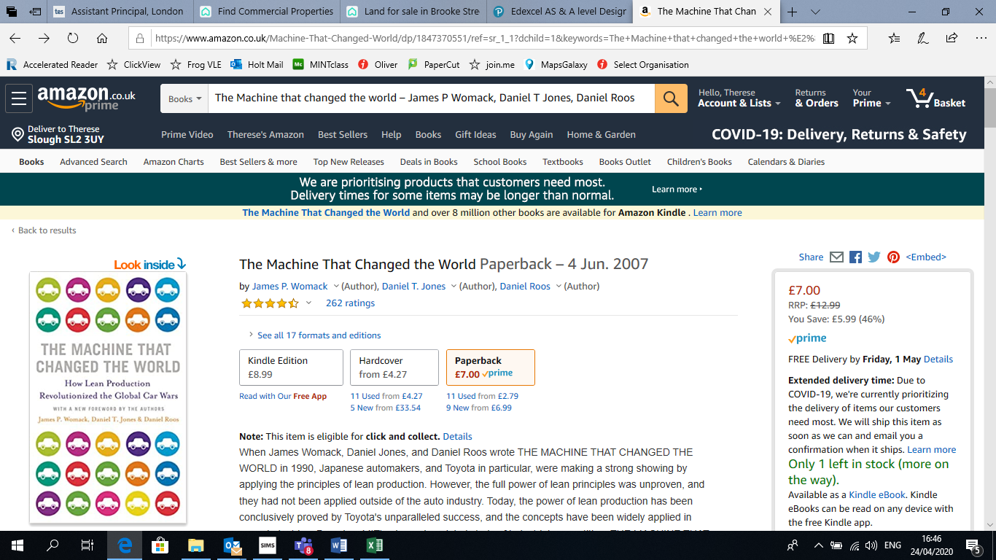
The Machine that changed the world – James P Womack, Daniel T Jones, Daniel Roos

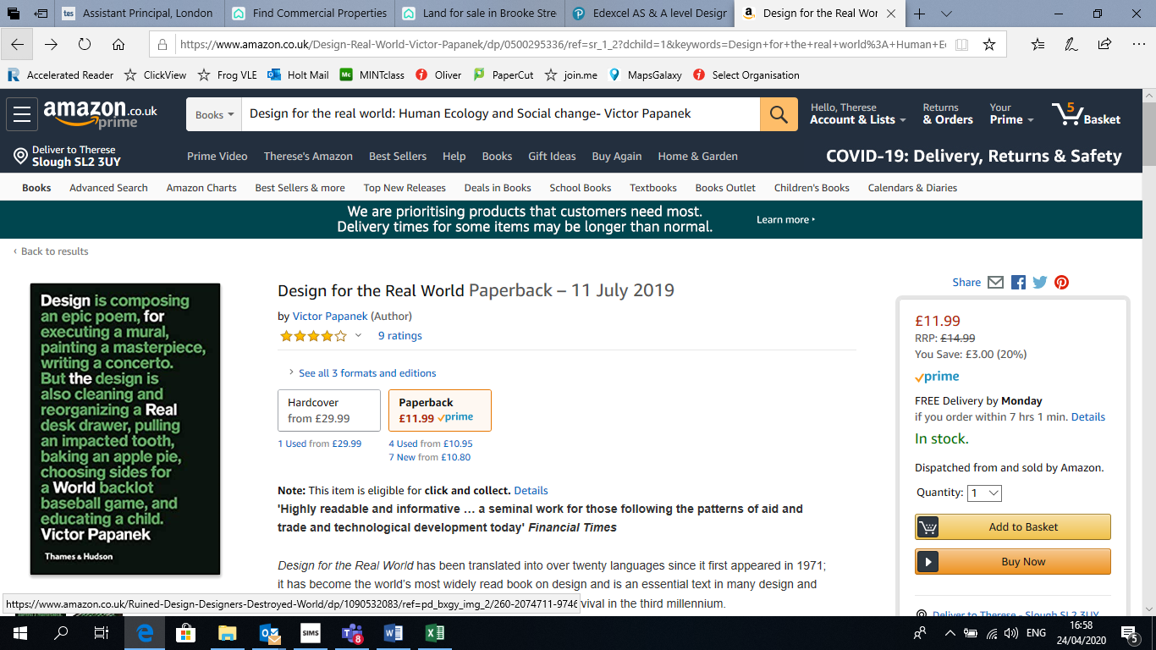
Design for the real world: Human Ecology and Social change- Victor Papanek

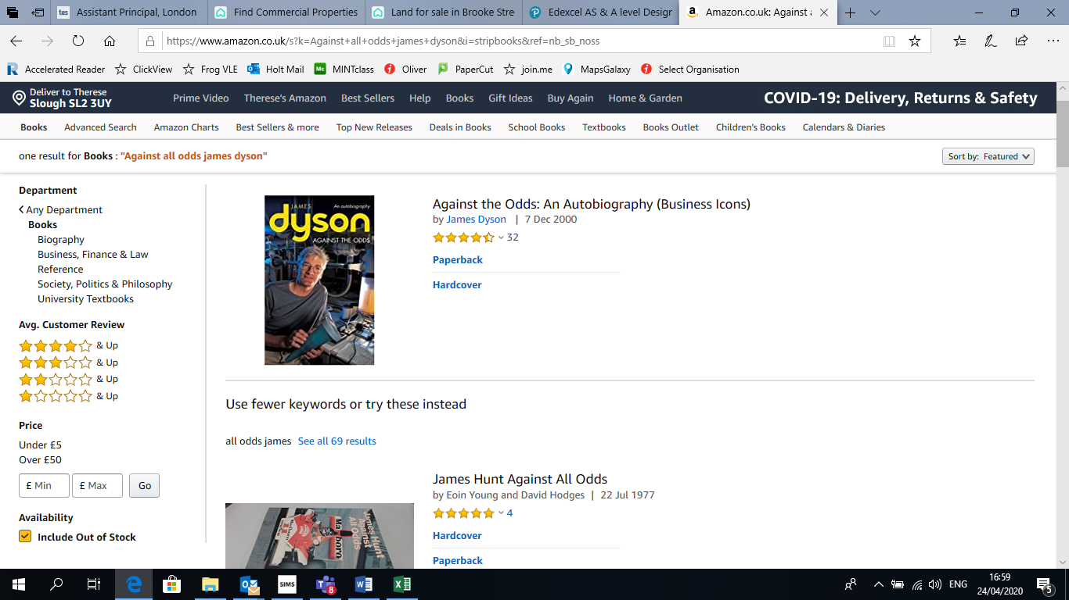
Against all odds- An autobiography- by James Dyson

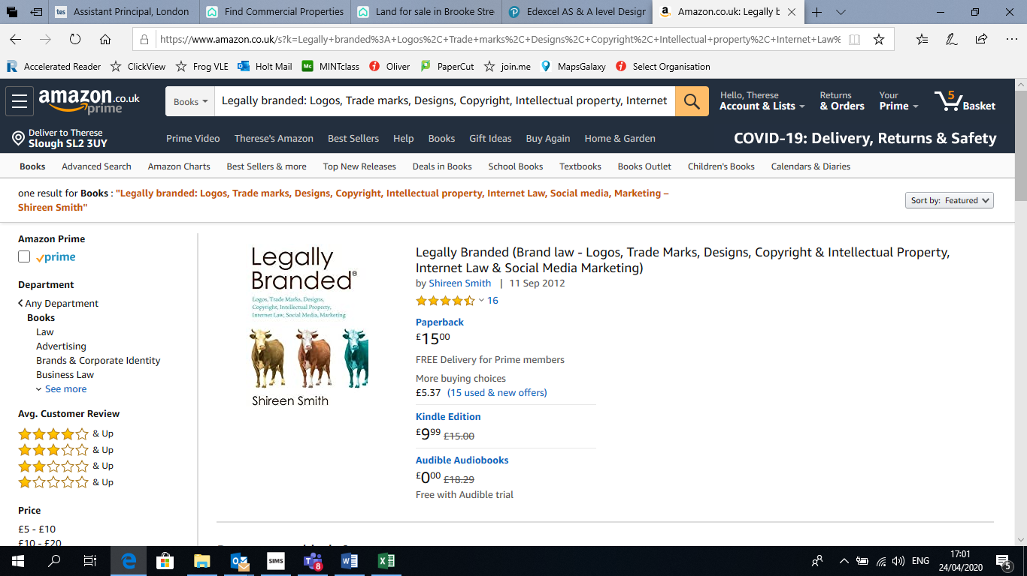
Legally branded: Logos, Trade marks, Designs, Copyright, Intellectual property, Internet Law, Social media, Marketing – Shireen Smith

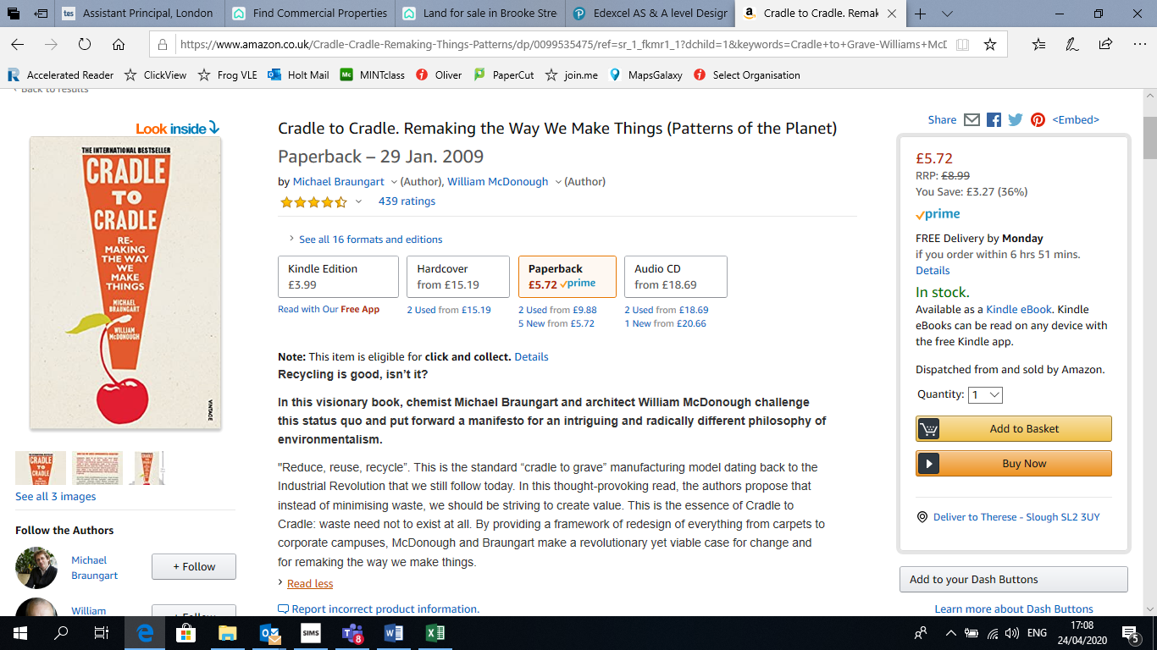
Cradle to Cradle-Williams McDonough

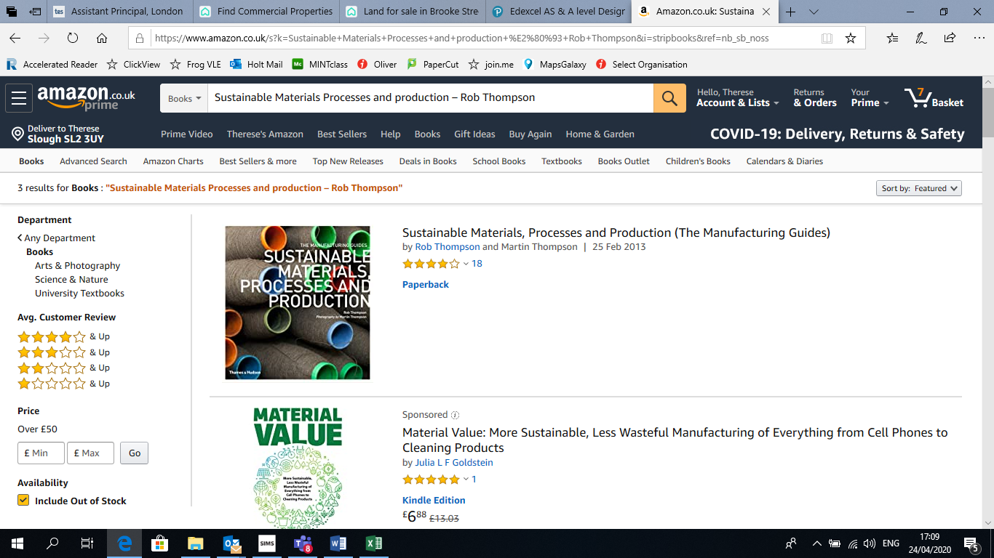
Sustainable Materials Processes and production – Rob Thompson

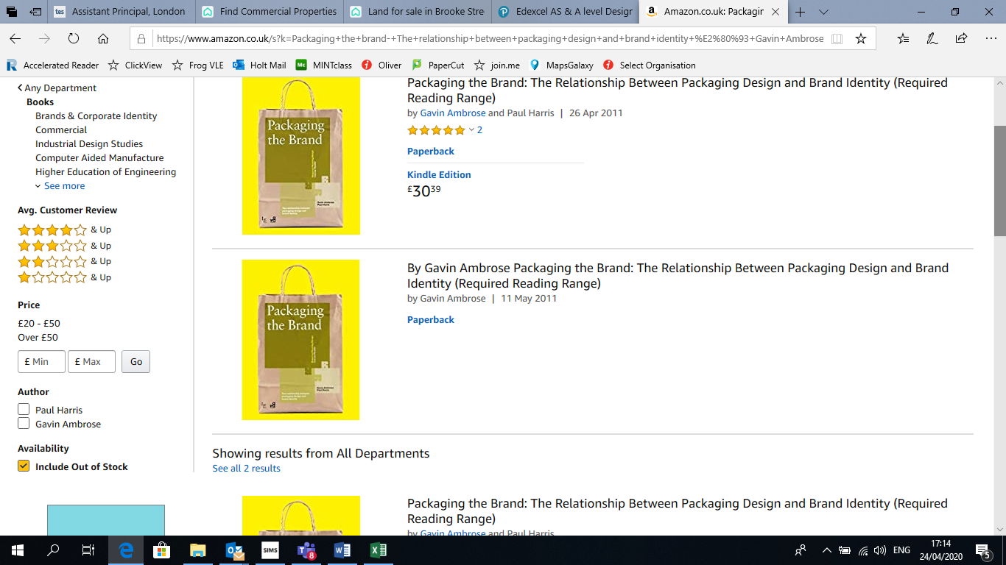
Packaging the brand- The relationship between packaging design and brand identity – Gavin Ambrose

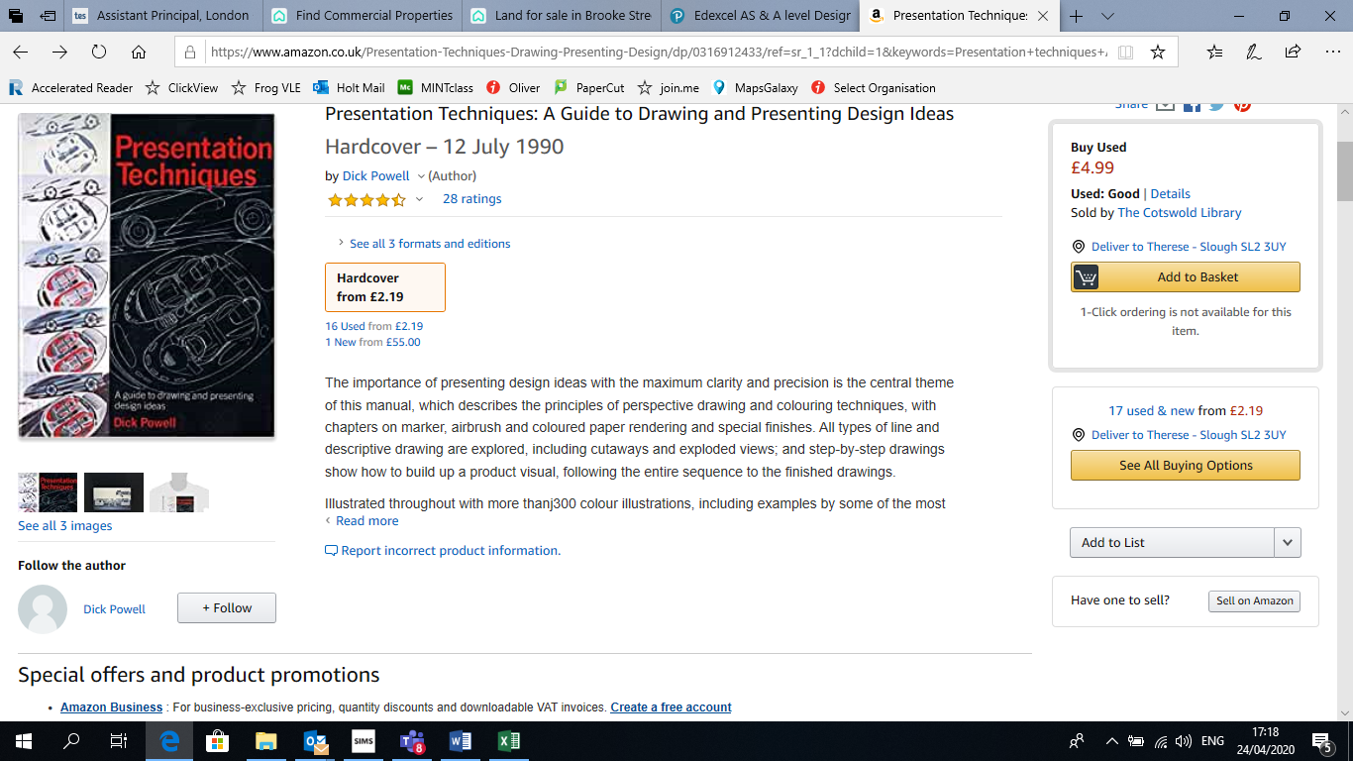
Presentation techniques A guide to drawing and presenting design ideas- Dick Powell

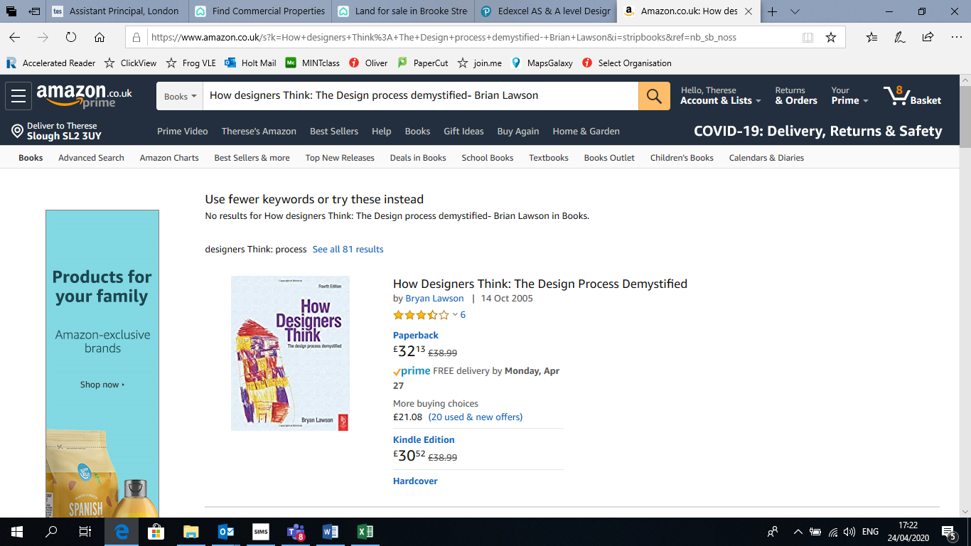
How designers Think: The Design Process Demystified- Brian Lawson

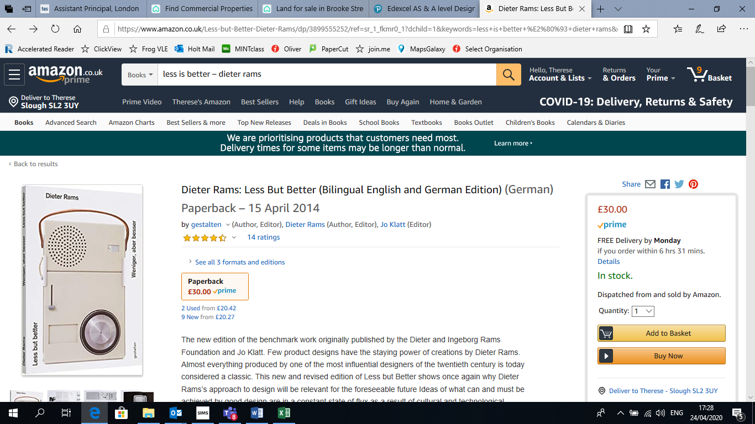
Less but better – Dieter Rams

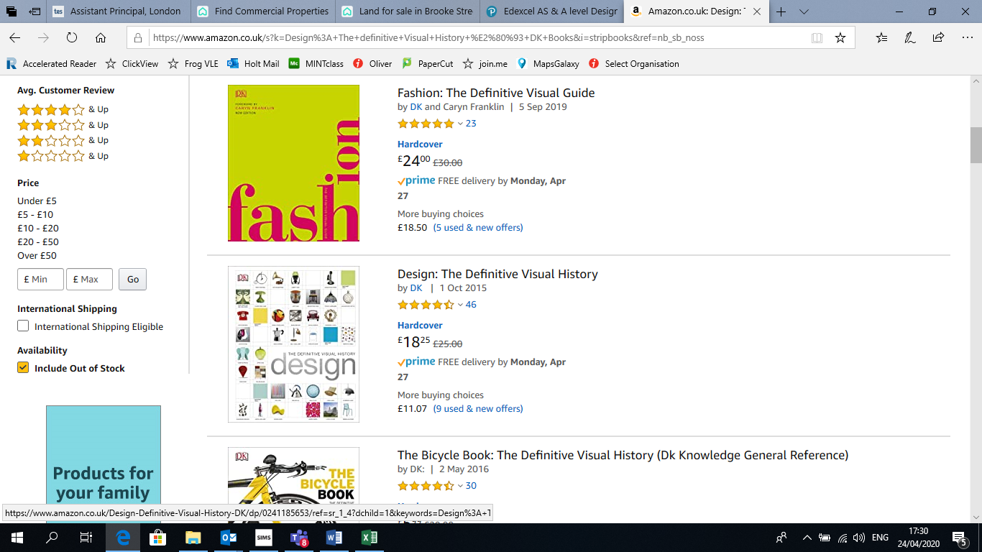
Design: The definitive Visual History – DK Books

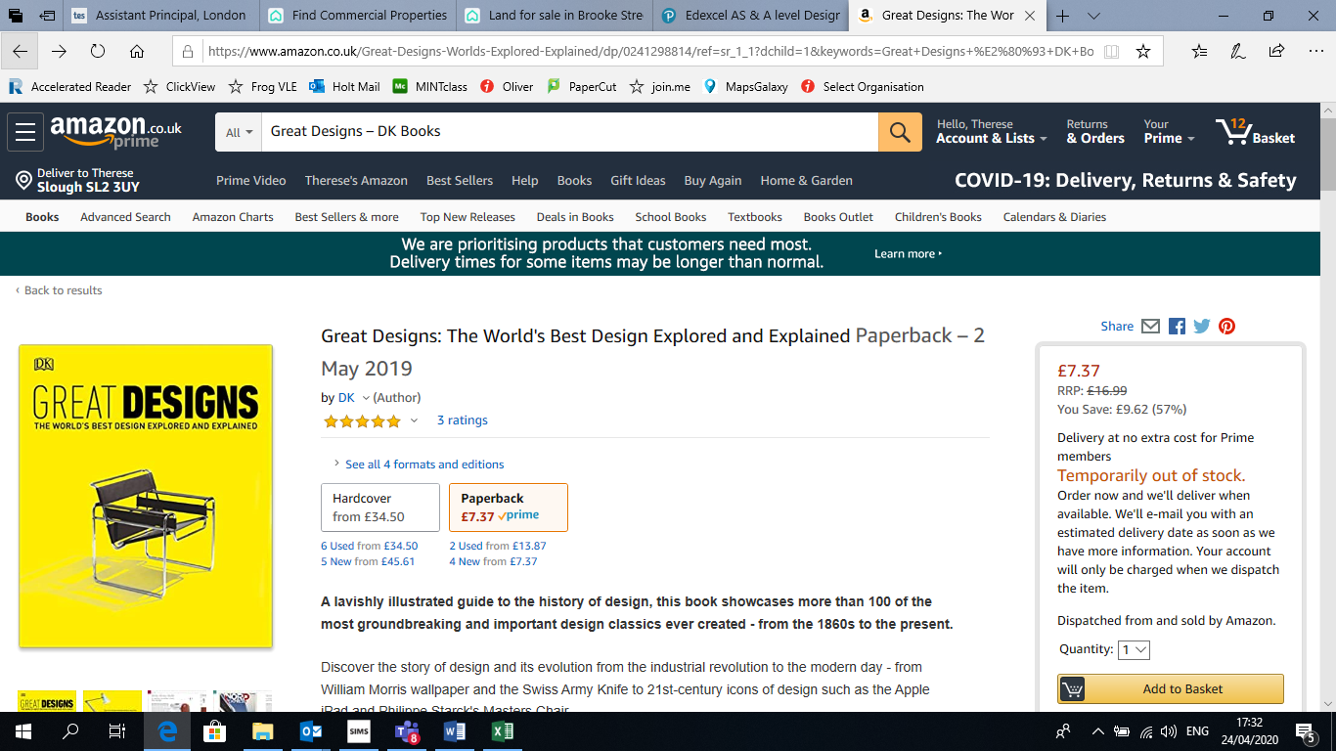
Great Designs – DK Books

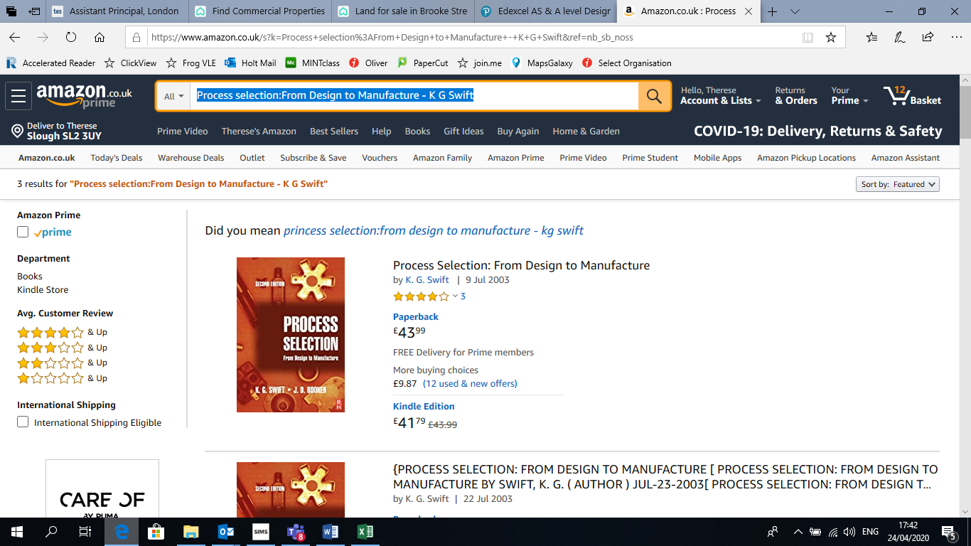
Process selection: From Design to Manufacture - K G Swift

Film/ Documentary Recommendations
There are a number of useful films and documentaries that will develop your wider understanding of the topics covered.
- Abstract: The Art of Design –Netflix's documentary series also available on YouTube. The series profiles eight of the most innovative thinkers working in design. Watch to learn about the creative processes of the leaders in architecture, interior design, fashion, photography, graphic design, illustration, and automobile design.
- Abstract: Season 2- Netflix's documentary series
- Helvetica - Directed by Gary Hustwit as part of the documentary design trilogy including 'Objectified' and 'Urbanized', Helvetica is a documentary about typography and graphic design. This film explores the history of the Helvetica typeface and they way it's shaped the world around us.
- Objectified- another film by Gary Hustwit, explores the extent that the design of everyday objects affects us. The film showcases the process of designing these objects and it profiles the graphic designers that create them.
- Urbanized- another film by Gary Hustwit explores urban design the language of the city.
- Design and Thinking is a documentary that examines the relationship between design and business. It shows how creative minds and business professionals can work collaboratively and strategically to create social change.
- Eames: The Architect and the Painter- Focus on the Eames office
- Hard Talk- BBC i-Player Stephen Sackur interviews Ola Kallenius, CEO of Daimler, one of Europe’s biggest vehicle manufacturers.
- How to Make series- BBC 4 Designer, Maker and materials engineer Zoe Laughlin explores The Trainer, The Tooth brush, and Headphones.
- Producttank- YouTube channel for prototype design
- YouTube- The three ways that good design makes you happy | Don Norman- design critic Don Norman turns his incisive eye toward beauty, fun, pleasure and emotion, as he looks at design that makes people happy. He names the three emotional cues that a well-designed product must hit to succeed. Show more
- There are many Product Design YouTube clips and TedTalks on Product Design

Research Activity
Using the internet and books, complete the following task. You should produce notes using the Cornell Note Taking System (http://lsc.cornell.edu/wp-content/uploads/2015/10/Cornell-Note_Taking-System.pdf) on the following topic(s).
Make sure you have your notes with you for your first lesson in September.
Research an iconic 20th Century designer.
Include political, social, economic and cultural influences on their style.
What Target Market Groups TMG were/are their typical clients?
Include a mood board that represents the characteristics of their designs/work.
Draw a selection (at least 6 ideas) of your own designs inspired by your chosen designer.
Include annotation, explanatory notes and potential materials and proposed manufacturing processes.

Pre-Knowledge Task
Please ensure you complete the following task in preparation for your September start.
Your teacher will ask to see it.
Choose a number of different items in your house and identify the materials and processes used to produce the product. Explain how they work and the reasons for their function also describe their form. Discuss which is more important the function or the form of the product. Your chosen items have a life cycle what is meant by this and do your items support sustainability.

Ideas for a Day Out
Visiting some of the places in the list below could be fun AND educational….
The Design Museum - 224-238 Kensington High St, London W8
The Victoria & Albert - Museum Cromwell Rd London
The Museum of Brands - 111-117 Lancaster Rd, London W11 1QT

Hackney Flea Market- 73A Stoke Newington Church St. London, N16 0AS

Liberty Store- Regent St, Carnaby, London W1B 5AH

The New Craftsmen, 34 North Row, Mayfair, London, thenewcraftsmen.com

Alessi, 22 Brook Street, WIK 5DF (020 7518 9091; www.alessi.com)

Jasper Morrison, 24b Kingsland Road, E2 8DA (www.jaspermorrison.com/Shop/)

SCP East, 135 Curtain Road, EC2A 3BX (020 7739 1869; www.scp.co.uk)
The Conran Store – Sloane Square Chelsea SW1W 8ER- famous for showcasing contemporary design in furnishings and household items, but also sells design classics.

Websites
A who’s who of who to follow on social media…..
www.bpf.co.uk The British Plastics federation
www.explainthatstuff.com/adhesives.html How forces make stuff stick, how adhesive products work
www.materialstoday.com finishing methods
https://www.taforum.org/directory/timber-trade-federation/
Timber trade federation
www.iso.org/iso/home.html The international organisation for standardisation
https://nextnature.net/story/2011/11-golden-rules-of-anthropomorphism-and-design-introduction
www.practicalaction.org Website that uses technology to challenges poverty in developing countries
www.ipo.gov.uk Website for IPO
www.recyclemore.co.uk
www.recyclenow.com
www.seymourpowell.com
www.eamesoffice.com
www.vitra.com/en-gb/corporation/designer/details/charles-ray-eames
www.designcouncil.org.uk
www.yankodesign.com
www.fairtrade.org.uk
www.tradingstandards.uk/consumers
www.bsigroup.com
www.jamesdysonfoundation.co.uk
www.apple.com/environment
www.wrap.org.uk
www.isixsigma.com/new-to-six-sigma/getting-started/what-six-sigma/
www.scrumalliance.org/why-scrum

Design project to complete: -
This is a design brief that you will be setting yourself, this is similar to what you will be doing for your NEA. Ensure you create a project that is a high standard of work. This work will look very good as part of a portfolio to take to University/career interviews.
Task: Design a useful household ‘gadget’ for the homewares market. (You are to identify a problem and design a solution to solve that problem)
Context: A Homewares distribution company have set the brief to design a gadget for the homewares market
Points to Cover:
- Unique selling point
- End User
- Materials
- Methods of Manufacture
- Form
- Function
- Who would typically retail the product
- Create a Brand or develop it along an existing product brand but ensure it works with the brand chosen
Presentation: Create a Digital presentation to a board of the ‘potential’ distributer to explain/’sell’ the product. This will be a PowerPoint presentation that will do all of the presenting without you being present. Present the ‘story’ of the process you have taken to find a solution (use photos). The story should follow finding/realising a problem the context/ the task, researching, designing, developing (including paper or card model making CAD (google sketch-up is free)), reaching a final solution - presentation drawing CAD or Freehand. The final design presentation should include:
- Multiple images to allow others to fully understand form and function
- Dimensions
- Materials with justification
- Expected manufacturing processes
- Safety features
- Sustainability or environmental factors
Ensure that you read the instructions and requirements carefully to ensure that there are no elements left out. If you have any questions, please contact me on ttu@holt.wokingham.sch.uk
TTU

